LAMPIRAN 1

GLOBAL WARMING POTENTIAL

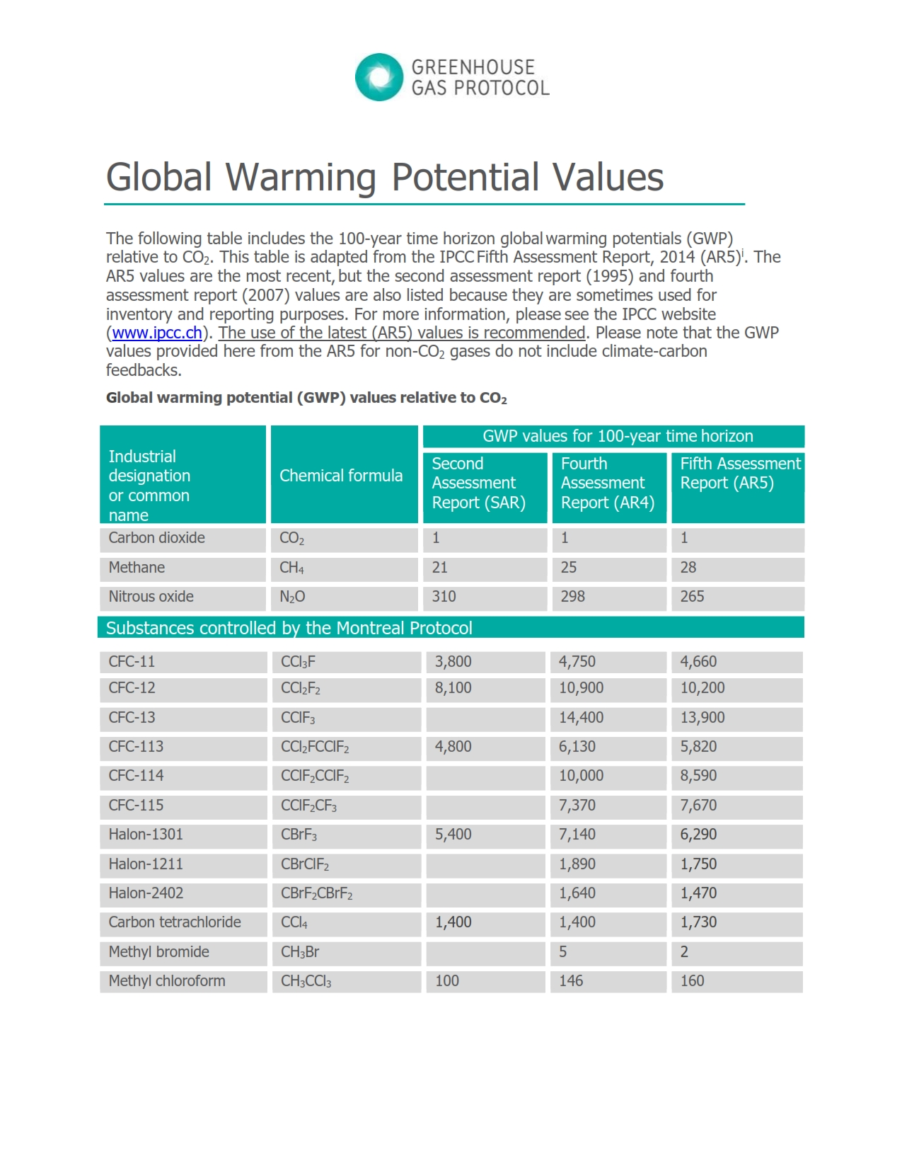

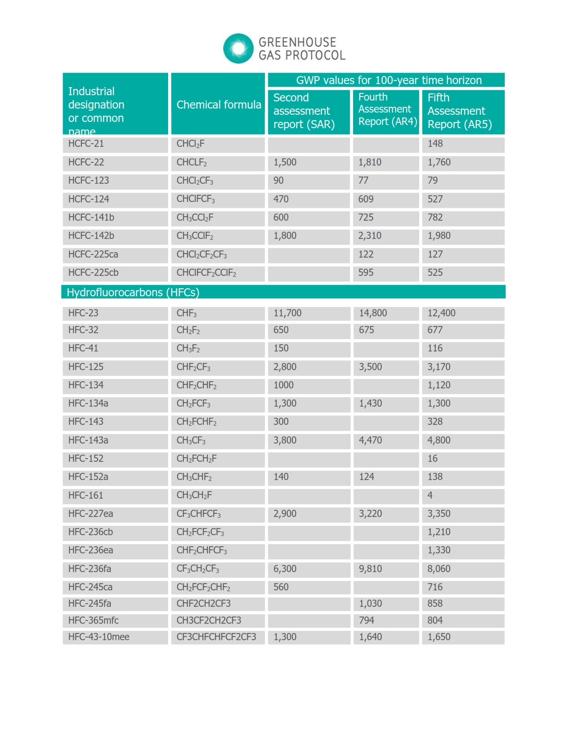

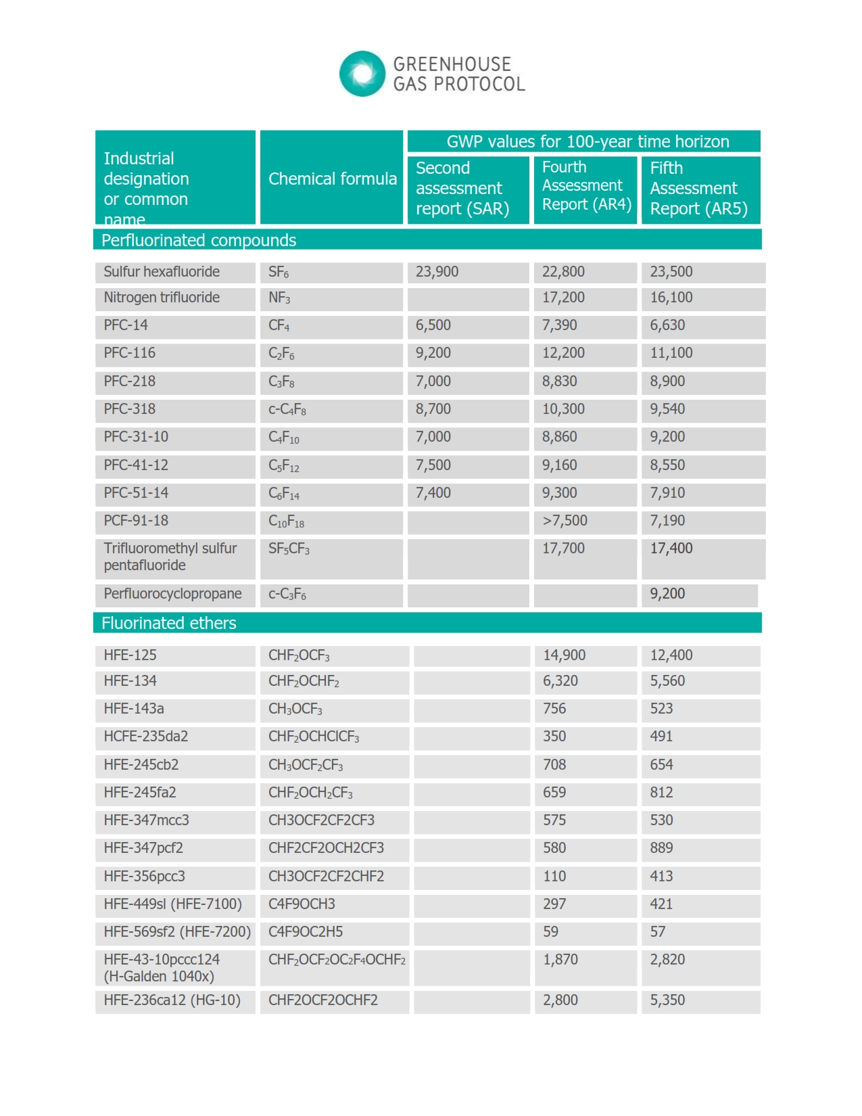

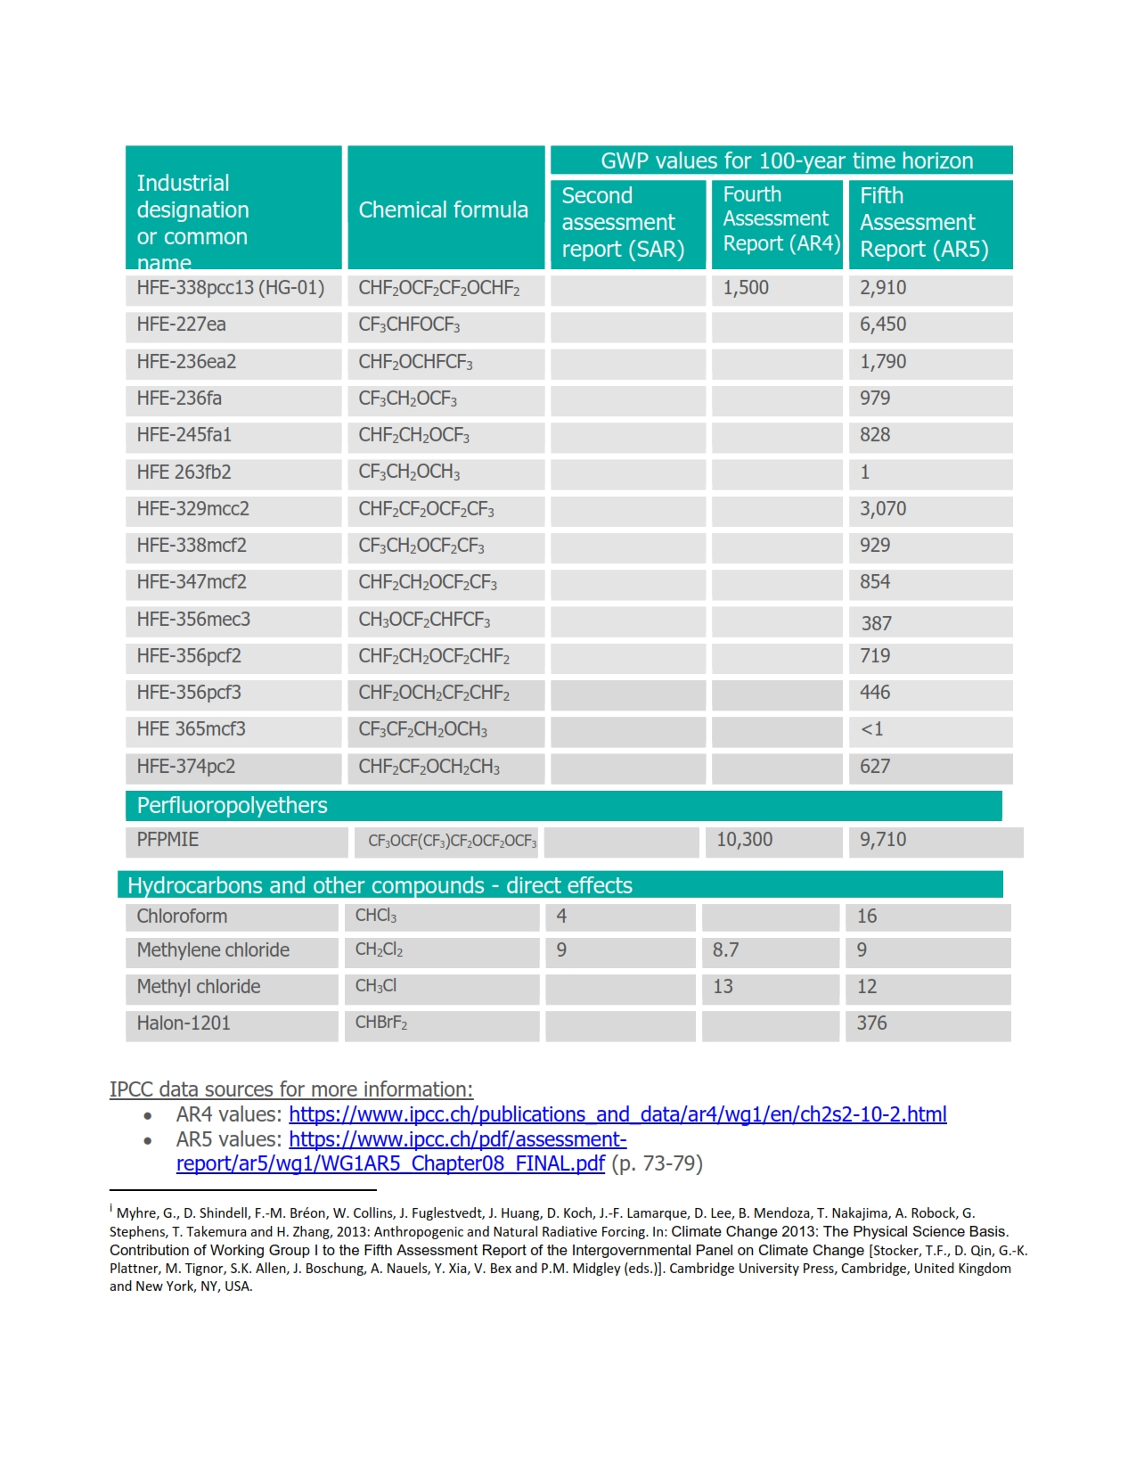

LAMPIRAN 2

PREDIKSI PENURUNAN EMISI PADA SEKTOR BERBASIS LAHAN

**LAMPIRAN 2.1. PREDIKSI PENURUNAN EMISI PADA SEKOTR TUTUPAN LAHAN / KEHUTANAN**

Tabel Lampiran 2. 1. Rencana Aksi Penurunan Emisi Gas Rumah Kaca Sektor Kehutanan

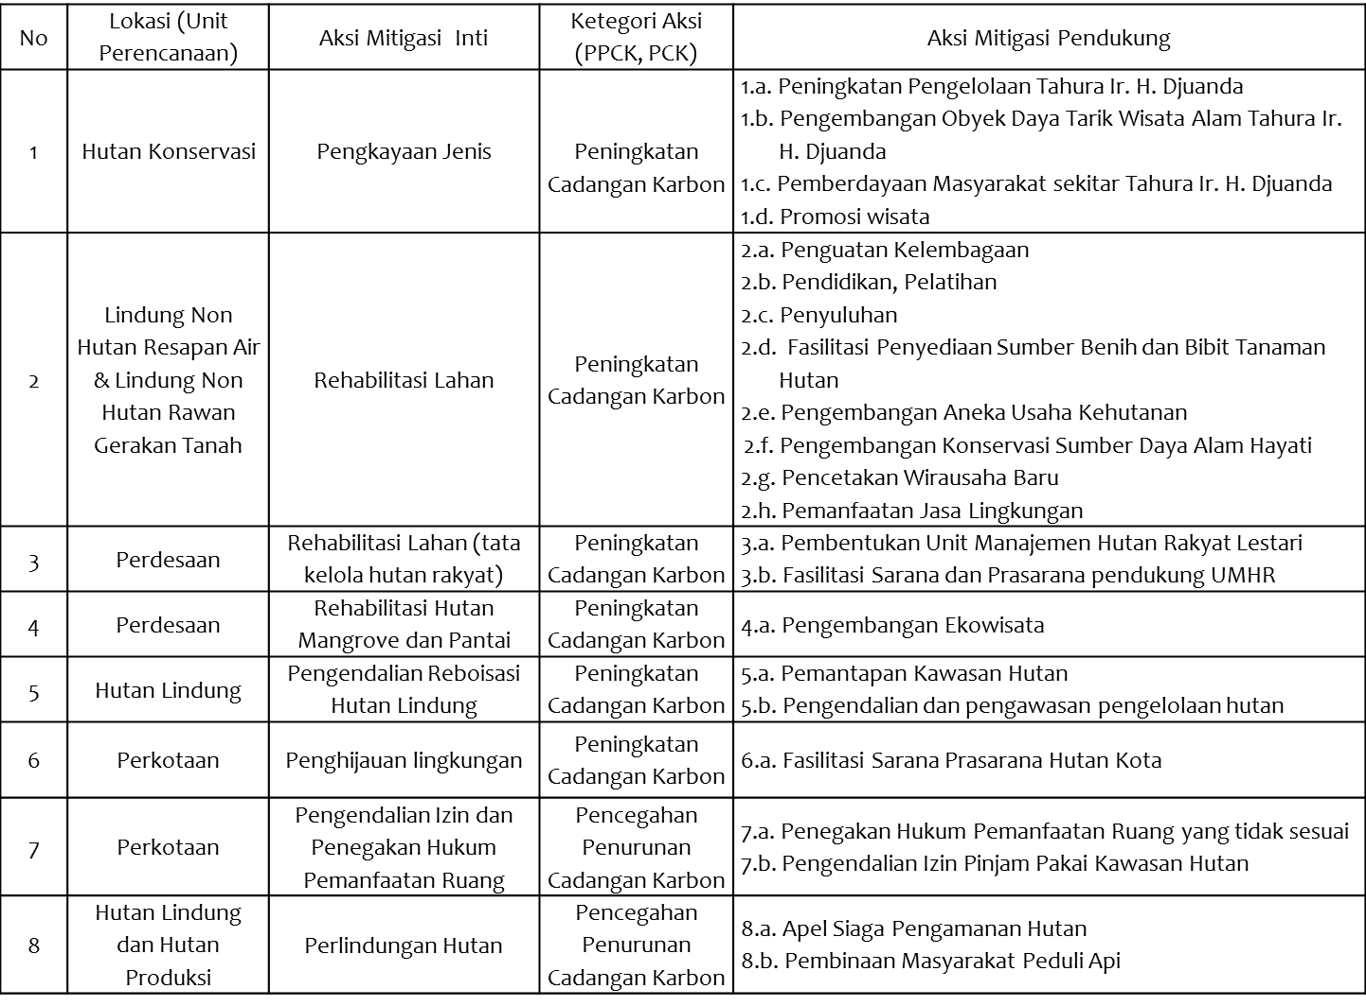

Tabel Lampiran 2. 2. Pendugaan Penurunan Emisi Gas Rumah Kaca Sektor Kehutanan Hasil Aksi Mitigasi (1)

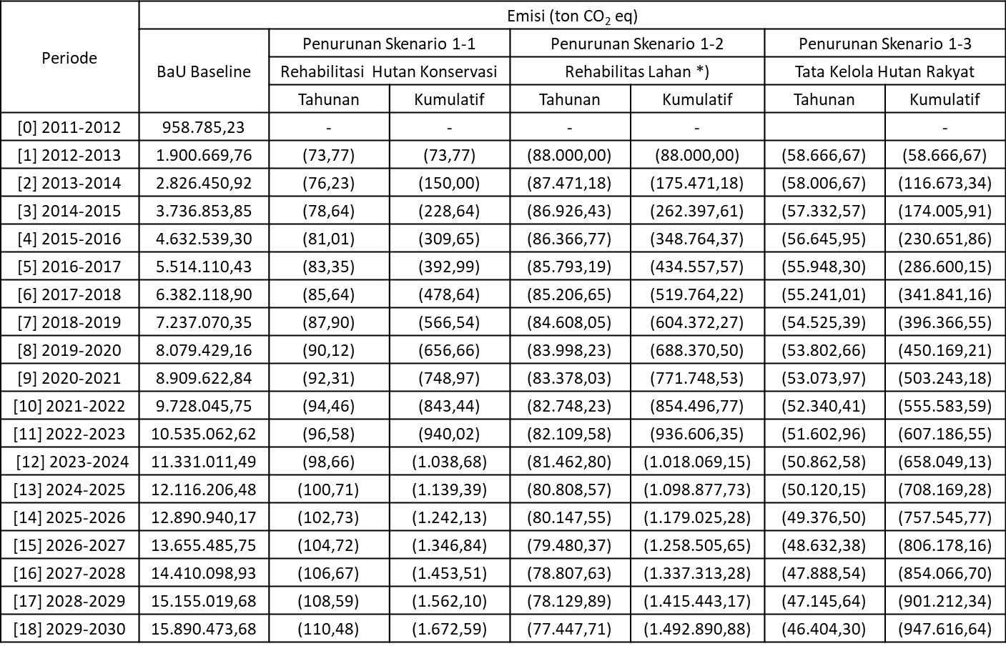

Tabel Lampiran 2. 3. Pendugaan Penurunan Emisi Gas Rumah Kaca Sektor Kehutanan Hasil Aksi Mitigasi (2)

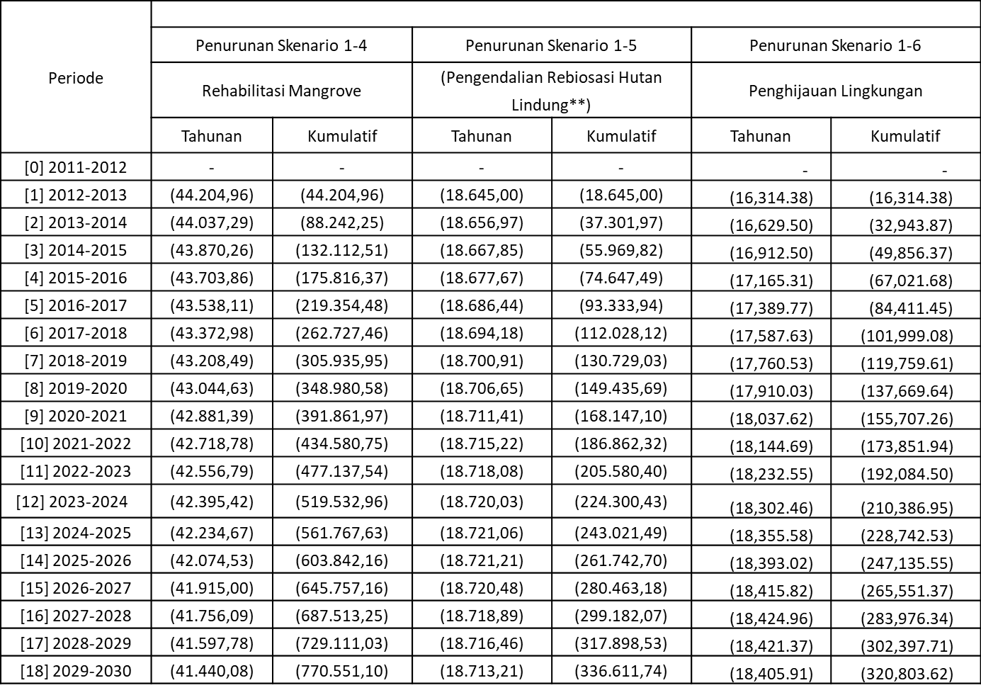

Tabel Lampiran 2. 4. Pendugaan Penurunan Emisi Gas Rumah Kaca Sektor Kehutanan Hasil Aksi Mitigasi (3)

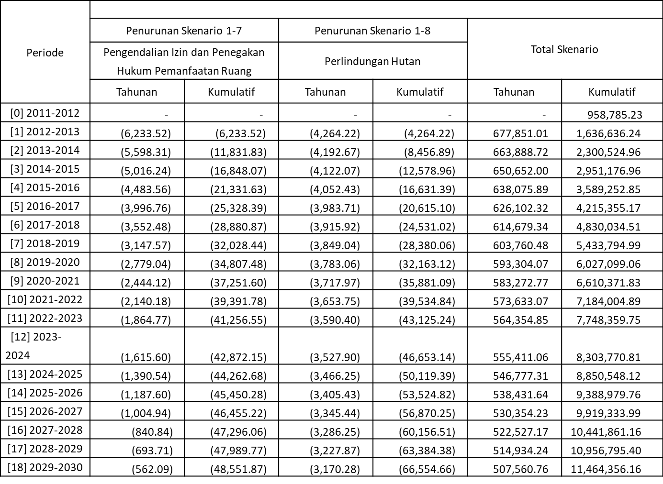

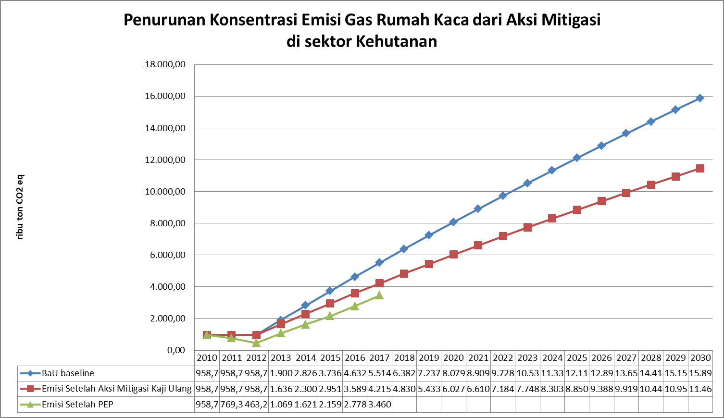

27,85%

Gambar Lampiran 2. 1. Penurunan Emisi GRK dari Aksi Mitigasi Sektor Kehutanan

**LAMPIRAN 2.2. PREDIKSI PENURUNAN EMISI PADA SEKTOR PERTANIAN**

Tabel Lampiran 2. 5.Data Aktivitas System of Rice Intensification (SRI) dan Penurunan Emisinya



Tabel Lampiran 2. 6.Data Aktivitas System of Rice Intensification (SRI) Hasil Prediksi Kecenderungan Volume beserta Penurunan Emisinya



Tabel Lampiran 2. 7.Data Aktivitas Pengelolaan Tanaman Terpadu (PTT) dan Penurunan Emisinya



Tabel Lampiran 2. 8.Data Aktivitas Pengelolaan Tanaman Terpadu (PTT) Hasil Prediksi Kecenderungan Volume beserta Penurunan Emisinya



Tabel Lampiran 2. 9.Data Aktivitas Unit Pengolahan Pupuk Organik (UPPO) dan Penurunan Emisinya



Tabel Lampiran 2. 10.Data Aktivitas Unit Pengolahan Pupuk Organik (UPPO) Hasil Prediksi Kecenderungan Volume beserta Penurunan Emisinya



Tabel Lampiran 2. 11. Rekapitulasi Penurunan Emisi Sektor Pertanian



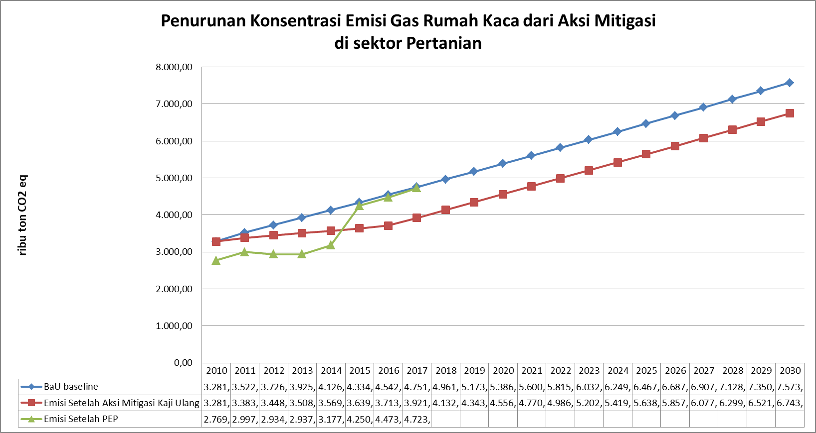

10,96%

Gambar Lampiran 2. 2. Penurunan Emisi GRK dari Aksi Mitigasi Sektor Pertanian

LAMPIRAN 3

PREDIKSI PENURUNAN EMISI PADA SEKTOR BERBASIS ENERGI

**LAMPIRAN 3.2. PREDIKSI PENURUNAN EMISI PADA SEKTOR ENERGI**

Tabel Lampiran 3. 1. Data Aktivitas Energi Baru dan Terbaharukan (EBT) yang Termasuk dalam Aksi Mitigasi Beserta Penurunan Emisinya

|  |  |  |  |  |
| --- | --- | --- | --- | --- |
| **Jenis PLT** | **Tahun** | **Satuan** | **Daya** | **Sumber Data** |
| PLTM | 2017 | MW | 22 | RUKD Jawa Barat |
| 2018 | MW | 42,99 | RUKD Jawa Barat |
| 2019 | MW | 17,8 | RUKD Jawa Barat |
| 2020 | MW | 41,82 | RUKD Jawa Barat |
| 2021 | MW | 63,88 | RUKD Jawa Barat |
| 2022 | MW | 17,344 | RUKD Jawa Barat |
| 2025 | MW | 23,4 | RUKD Jawa Barat |
| 2020 | MW | 100 | RUKD Jawa Barat |
| PLTSa | 2019 | MW | 10 | RUKD Jawa Barat |
|  | 2020 | MW | 10 | Perencanaan DLH Prov Jabar, dan besarnya kapasitas listrik dari asumsi |
|  | 2022 | MW | 10 |
|  | 2023 | MW | 10 |
| PLT PS (Asumsi realisasi : 60%) | 2021 | MW | 520 | RUKD Jawa Barat |
| 2022 | MW | 520 | RUKD Jawa Barat |

Tabel Lampiran 3. 2. Data Aktivitas dan Perhitungan Penurunan Emisi untuk Aksi Mitigasi Efisiensi Energi (PJU Solar Cell)

| **No** | **Wilayah Pembangunan** | **Ruas Jalan** | **Tahun Anggaran** | **Jumlah Sollar Cell** |
| --- | --- | --- | --- | --- |
| 1 | WP I |  |  |  |
| Kota Bogor, Kab. Bogor, Kota Sukabumi, Kab, Sukabumi, Kab. Cianjur, Kota Depok | Kab. Sukabumi - Jl. Lingkar Sekatan Sukabumi | 2013 | 6 |
| Kota Bogor - Jl. Abdullah bin Nuh dan Jl. Dramaga | 2013 | 6 |
| Cianjur - Cariu - Jonggol | 2014 | 35 |
| 2 | WP II |  |  |  |
| Kab. Subang, Kab. Karawang, Kab. Purwakarta, Kab. Bekasi, Kota Bekasi | Kab. Karawang - Jl. Lingkar Karawang | 2013 | 5 |
| Kab. Purwakarta, Jl. Sadang - Subang (Cibatu) | 2013 | 5 |
| Kab. Subang, Jl. Lembang - Subang (Cijambe) | 2013 | 5 |
| Ruas Jalan Subang - Sumedang dan Sadang - Subang - Cikamurang | 2014 | 65 |
| 3 | WP III |  |  |  |
| Kota Cirebon, Kab. Cirebon, Kab. Majalengka, Kab. Indramayu, Kab. Kuningan | Kab. Indramayu, Jl. Karang Ampel - jatibarang | 2013 | 8 |
| Kab. Kuningan, Jl. Kuningan - Ciledug & Kuningan - Cikijing | 2013 | 7 |
| Ruas Jalan Jatibarang - Jati Tujuh | 2014 | 35 |
| 4 | WP IV |  |  |  |
| Bagian Timur : Kab. Garut, Kab. Tasikmalaya, Kab. Ciamis, Kota Tasikmlaya, Kota Banjar, Kab. Pangandaran | Ruas Jalan Provinsi Garut - Singaparna | 2012 | 20 |
| Singaparna - Tasikmalaya | 2012 | 10 |
| Tasikmalaya - Manonjaya | 2012 | 20 |
| Kadipaten Majalengka | 2012 | 10 |
| Kota Tasikmalaya, Jl. Manonjaya | 2013 | 5 |
| Kabupaten Tasikmalaya, Jl. Singaparna - Garut (Kp. Naga) | 2013 | 5 |
| Kabupaten Ciamis, Jl. Ciamis - Kawali | 2013 | 5 |
| Ruas Jalan Sasak Beusi - Cibatu - Leuwi Goong - Leles dan Ruas Jalan Sumedang - Wado | 2014 | 34 |
| 5 | WP IV |  |  |  |
| Bagian Tengah : Kab. Bandung, Kab. Bandung Barat, Kab. Sumedang, Kota Bandung, Kota Cimahi | Kota Bandung, Jl. Pajajaran | 2013 | 5 |
| Kab. Bandung Barat, Jl. Kolonel Masturi | 2013 | 10 |
| Ruas Jalan tasikmalaya - Manonjaya dan Ruas Jalan Ciamis - Kawali (Ciamis - Baregbeg) | 2014 | 20 |
| Ruas Jalan Kopo - Soreang | 2015 | 17 |
| Ruas Jalan Soreang - Batujajar - Cimareme | 2015 | 17 |
| Ruas Jalan Cimahi - Cisarua - Lembang/Jl. Kolonel Masturi | 2015 | 17 |
| **Total PJU Solar Cell** | | | | **372** |

Sumber : Dinas Perhubungan Jawa Barat, 2018

Tabel Lampiran 3. 3. Data Aktivitas dan Perhitungan Penurunan Emisi untuk Aksi Mitigasi Efisiensi Energi (PJU Solar Cell) Tahun 2018

|  |  |  |  |  |  |
| --- | --- | --- | --- | --- | --- |
| **LOKASI** | **Lampu terpasang sampai dengan 2018** | | | | |
| **jumlah** | **daya lama (lampu pijar, watt)** | **Daya baru (lampu LED, watt)** | **Keterangan referensi jumlah lampu** | **keterangan daya** |
| Kota Sukabumi | 189 | 150 | 90 | 474 x 40% = 189 | Asumsi lampu SON-T 150 watt digantikan oleh LED 90 watt |
| Kabupaten Cianjur | 705 | 150 | 90 | 705 |
| Kota Cimahi | 863 | 150 | 90 | 863 jalan umum |
| 291 | 100 | 60 | 291 jalan lingkungan | Asumsi lampu SON-T 100 watt digantikan oleh LED 60 watt |
|  |  | 30 | 10 | 5836 gang |  |

Tabel Lampiran 3. 4. Data Aktivitas dan Perhitungan Penurunan Emisi untuk Pembangunan PLT Hybrid Rooftop

|  |  |  |  |  |  |  |  |  |  |
| --- | --- | --- | --- | --- | --- | --- | --- | --- | --- |
| Pembangunan Energi Terbarukan *Off Grid* | | | | | | | | | |
| Tahun | Rencana Aksi | Indikator | Parameter | Daya terpasang (KWp) | Daya terpasang (MW) | *Operating Hours* (Jam) | Data Aktivitas (MWh) | Faktor Emisi JAMALI (tCO2e/MWh) | Penurunan Emisi (tCO2e) |
| 2017 | Pembangunan PLT *Hybrid* (Bayu dan Surya) | MWh | Daya terpasang & Waktu beroperasi (20%X8760) | 12,00 | 0,060000 | 1752 | 105,12 | 0,862 | 90,61 |
| 2018 | 0,00 | 0,000000 | 1752 | 0 | 0,862 | 0,00 |
| 2019 | 28,80 | 0,144000 | 1752 | 252,288 | 0,862 | 217,47 |
| 2020 | 28,80 | 0,144000 | 1752 | 252,288 | 0,862 | 217,47 |
| 2021 | 28,80 | 0,144000 | 1752 | 252,288 | 0,862 | 217,47 |
| 2022 | 28,80 | 0,144000 | 1752 | 252,288 | 0,862 | 217,47 |
| 2023 | 28,80 | 0,144000 | 1752 | 252,288 | 0,862 | 217,47 |
| 2024 | 28,80 | 0,144000 | 1752 | 252,288 | 0,862 | 217,47 |
| 2025 | 28,80 | 0,144000 | 1752 | 252,288 | 0,862 | 217,47 |
| 2026 | 28,80 | 0,144000 | 1752 | 252,288 | 0,862 | 217,47 |
| 2027 | 28,80 | 0,144000 | 1752 | 252,288 | 0,862 | 217,47 |
| 2028 | 28,80 | 0,144000 | 1752 | 252,288 | 0,862 | 217,47 |
| 2029 | 28,80 | 0,144000 | 1752 | 252,288 | 0,862 | 217,47 |
| 2030 | 28,80 | 0,144000 | 1752 | 252,288 | 0,862 | 217,47 |

Tabel Lampiran 3. 5. Data Aktivitas dan Perhitungan Penurunan Emisi untuk PLT Pumpstorage

|  |  |  |  |  |  |  |  |  |
| --- | --- | --- | --- | --- | --- | --- | --- | --- |
| Pembangunan Energi Terbarukan *Off Grid* | | | | | | | | |
| Tahun | Rencana Aksi | Indikator | Parameter | Daya terpasang (MW) | *Operating Hours* (Jam) | Data Aktivitas (MWh) | Faktor Emisi PLTD (tCO2e/MWh) | Penurunan Emisi (tCO2e) |
| 2021 | Pembangunan PLT PUMP STORAGE | MWh | Daya terpasang & Waktu Beroperasi (70%X8760) | 312 | 6132 | 1913184 | 0,706 | 1350708 |
| 2022 | Pembangunan PLT PUMP STORAGE | MWh | Daya terpasang & Waktu Beroperasi (70%X8760) | 312 | 6132 | 1913184 | 0,706 | 1350708 |

Tabel Lampiran 3. 6. Data Aktivitas dan Perhitungan Penurunan Emisi untuk PLTB

|  |  |  |  |  |  |  |  |  |
| --- | --- | --- | --- | --- | --- | --- | --- | --- |
| Pembangunan Energi Terbarukan *Off Grid* | | | | | | | | |
| Tahun | Rencana Aksi | Indikator | Parameter | Daya terpasang (MW) | *Operating Hours* (Jam) | Data Aktivitas (MWh) | Faktor Emisi PLTD (tCO2e/MWh) | Penurunan Emisi (tCO2e) |
| 2019 | Pembangunan PLTB | MWh | Daya terpasang & Waktu beroperasi (20%X8760) | 100 | 1752 | 175200 | 0,706 | 123691 |
| 2020 | Pembangunan PLTB | MWh | Daya terpasang & Waktu beroperasi (20%X8760) | 100 | 1752 | 175200 | 0,706 | 123691 |

Tabel Lampiran 3. 7. Data Aktivitas dan Perhitungan Penurunan Emisi untuk PLTM OFF GRID

| **Tahun** | **Rencana Aksi** | **Indikator** | **Parameter** | **Daya terpasang (MW)** | ***Operating Hours* (Jam)** | **Data Aktivitas (MWh)** | **Faktor Emisi PLTD (tCO2e/MWh)** | **Penurunan Emisi (tCO2e)** |
| --- | --- | --- | --- | --- | --- | --- | --- | --- |
| 2010 | Pembangunan PLTM | MWh | Daya terpasang & Waktu Beroperasi (70%X8760) | 1,79 | 6132 | 10.976 | 0,706 | 7.749,25 |
| 2011 | 1,10 | 6132 | 6.745 | 0,706 | 4.762,11 |
| 2012 | 0,00 | 6132 | - | 0,706 | 0,00 |
| 2013 | 5,30 | 6132 | 32.500 | 0,706 | 22.944,72 |
| 2014 | 8,00 | 6132 | 49.056 | 0,706 | 34.633,54 |
| 2015 | 31,40 | 6132 | 192.545 | 0,706 | 135.936,63 |
| 2016 | 3,00 | 6132 | 18.396 | 0,706 | 12.987,58 |
| 2017 | 30,60 | 6132 | 187.639 | 0,706 | 132.473,28 |
| 2018 | 17,80 | 6132 | 109.150 | 0,706 | 77.059,62 |
| 2019 | 41,82 | 6132 | 256.440 | 0,706 | 181.046,81 |
| 2020 | 63,88 | 6132 | 391.712 | 0,706 | 276.548,78 |
| 2021 | 17,34 | 6132 | 106.353 | 0,706 | 75.085,51 |
| 2022 |  | 6132 | - | 0,706 | 0,00 |
| 2023 |  | 6132 | - | 0,706 | 0,00 |
| 2024 | 23,40 | 6132 | 143.489 | 0,706 | 101.303,09 |
| 2025 |  | 6132 | - | 0,706 | 0,00 |
| 2026 |  | 6132 | - | 0,706 | 0,00 |
| 2027 |  | 6132 | - | 0,706 | 0,00 |
| 2028 |  | 6132 | - | 0,706 | 0,00 |
| 2029 |  | 6132 | - | 0,706 | 0,00 |
| 2030 |  | 6132 | - | 0,706 | 0,00 |

Tabel Lampiran 3. 8. Data Aktivitas dan Perhitungan Penurunan Emisi untuk PLTMH OFF GRID

| **Tahun** | **Rencana Aksi** | **Indikator** | **Parameter** | **Daya terpasang (MW)** | ***Operating Hours* (Jam)** | **Data Aktivitas (MWh)** | **Faktor Emisi PLTD (tCO2e/MWh)** | **Penurunan Emisi (tCO2e)** |
| --- | --- | --- | --- | --- | --- | --- | --- | --- |
| 2010 | Pembangunan PLTM | MWh | Daya terpasang & Waktu Beroperasi (70%X8760) | 0,0664 | 6132 | 407 | 0,706 | 287,46 |
| 2011 | 0,0160 | 6132 | 98 | 0,706 | 69,27 |
| 2012 | 0,0001 | 6132 | 1 | 0,706 | 0,43 |
| 2013 | 0,0000 | 6132 | - | 0,706 | 0,00 |
| 2014 | 8,0000 | 6132 | 49.056 | 0,706 | 34.633,54 |
| 2015 | 0,0000 | 6132 | - | 0,706 | 0,00 |
| 2016 | 8,0000 | 6132 | 49.056 | 0,706 | 34.633,54 |
| 2017 | 0,6300 | 6132 | 3.863 | 0,706 | 2.727,39 |
| 2018 | 0,0082 | 6132 | 50 | 0,706 | 35,30 |
| 2019 | 0,0082 | 6132 | 50 | 0,706 | 35,30 |
| 2020 | 0,0082 | 6132 | 50 | 0,706 | 35,30 |
| 2021 | 0,0082 | 6132 | 50 | 0,706 | 35,30 |
| 2022 | 0,0082 | 6132 | 50 | 0,706 | 35,30 |
| 2023 | 0,0082 | 6132 | 50 | 0,706 | 35,30 |
| 2024 | 0,0082 | 6132 | 50 | 0,706 | 35,30 |
| 2025 | 0,0082 | 6132 | 50 | 0,706 | 35,30 |
| 2026 | 0,0082 | 6132 | 50 | 0,706 | 35,30 |
| 2027 | 0,0082 | 6132 | 50 | 0,706 | 35,30 |
| 2028 | 0,0082 | 6132 | 50 | 0,706 | 35,30 |
| 2029 | 0,0082 | 6132 | 50 | 0,706 | 35,30 |
| 2030 | 0,0082 | 6132 | 50 | 0,706 | 0,00 |

Tabel Lampiran 3. 9. Data Aktivitas dan Perhitungan Penurunan Emisi untuk PLTSa

|  |  |  |  |  |  |  |  |  |  |
| --- | --- | --- | --- | --- | --- | --- | --- | --- | --- |
| **PLTSa** | **Tahun** | **Rencana Aksi** | **Indikator** | **Parameter** | **Daya terpasang (MW)** | ***Operating Hours* (Jam)** | **Data Aktivitas (MWh)** | **Faktor Emisi PLTD (tCO2e/MWh)** | **Penurunan Emisi (tCO2e)** |
| Lulut Nambo |  | Pembangunan PLTSa | MWh | Daya terpasang & Waktu Beroperasi (70%X8760) | 10 | 6132 | 61320 | 0,706 | 43.292 |
| Legoknangka | 2019 | Pembangunan PLTSa | MWh | Daya terpasang & Waktu Beroperasi (70%X8760) | 10 | 6132 | 61320 | 0,706 | 43.292 |
| Ciayumajakuning | 2019 | Pembangunan PLTSa | MWh | Daya terpasang & Waktu Beroperasi (70%X8760) | 10 | 6132 | 61320 | 0,706 | 43.292 |
| Bekarpur | 2019 | Pembangunan PLTSa | MWh | Daya terpasang & Waktu Beroperasi (70%X8760) | 10 | 6132 | 61320 | 0,706 | 43.292 |

Tabel Lampiran 3. 9. Data Aktivitas dan Perhitungan Penurunan Emisi untuk PJU LED Kelompok Jalan Umum

| **tahun** | **Indikator** | **Parameter** | **Energi *Baseline* (MW)** | **Energi Setelah Pemasangan Sistem PJU (MW)** | **Data Aktivitas (Penghematan) MW** | ***Operating Hours* (Jam)** | **MWh** | **Faktor Emisi* (tCO2e/MWh)** | **Penurunan Emisi (tCO2e) Per titik lampu** | **JUMLAH LAMPU (buah)** | **Penurunan Emisi (tCO2e) Total** |
| --- | --- | --- | --- | --- | --- | --- | --- | --- | --- | --- | --- |
| 2010 | MWh | Besarnya penghematan | 0,00015 | 0,00009 | 0,00006 | 4380 | 0,2628 | 0,862 | 0,226534 | 0 | 0,00000 |
| 2011 | MWh | Besarnya penghematan | 0,00015 | 0,00009 | 0,00006 | 4380 | 0,2628 | 0,862 | 0,226534 | 218 | 49,38432 |
| 2012 | MWh | Besarnya penghematan | 0,00015 | 0,00009 | 0,00006 | 4380 | 0,2628 | 0,862 | 0,226534 | 219 | 49,61086 |
| 2013 | MWh | Besarnya penghematan | 0,00015 | 0,00009 | 0,00006 | 4380 | 0,2628 | 0,862 | 0,226534 | 219 | 49,61086 |
| 2014 | MWh | Besarnya penghematan | 0,00015 | 0,00009 | 0,00006 | 4380 | 0,2628 | 0,862 | 0,226534 | 220 | 49,83739 |
| 2015 | MWh | Besarnya penghematan | 0,00015 | 0,00009 | 0,00006 | 4380 | 0,2628 | 0,862 | 0,226534 | 220 | 49,83739 |
| 2016 | MWh | Besarnya penghematan | 0,00015 | 0,00009 | 0,00006 | 4380 | 0,2628 | 0,862 | 0,226534 | 220 | 49,83739 |
| 2017 | MWh | Besarnya penghematan | 0,00015 | 0,00009 | 0,00006 | 4380 | 0,2628 | 0,862 | 0,226534 | 220 | 49,83739 |
| 2018 | MWh | Besarnya penghematan | 0,00015 | 0,00009 | 0,00006 | 4380 | 0,2628 | 0,862 | 0,226534 | 221 | 50,06393 |
| 2019 | MWh | Besarnya penghematan | 0,00015 | 0,00009 | 0,00006 | 4380 | 0,2628 | 0,862 | 0,226534 | 221 | 50,06393 |
| 2020 | MWh | Besarnya penghematan | 0,00015 | 0,00009 | 0,00006 | 4380 | 0,2628 | 0,862 | 0,226534 | 221 | 50,06393 |
| 2021 | MWh | Besarnya penghematan | 0,00015 | 0,00009 | 0,00006 | 4380 | 0,2628 | 0,862 | 0,226534 | 221 | 50,06393 |
| 2022 | MWh | Besarnya penghematan | 0,00015 | 0,00009 | 0,00006 | 4380 | 0,2628 | 0,862 | 0,226534 | 221 | 50,06393 |
| 2023 | MWh | Besarnya penghematan | 0,00015 | 0,00009 | 0,00006 | 4380 | 0,2628 | 0,862 | 0,226534 | 221 | 50,06393 |
| 2024 | MWh | Besarnya penghematan | 0,00015 | 0,00009 | 0,00006 | 4380 | 0,2628 | 0,862 | 0,226534 | 221 | 50,06393 |
| 2025 | MWh | Besarnya penghematan | 0,00015 | 0,00009 | 0,00006 | 4380 | 0,2628 | 0,862 | 0,226534 | 221 | 50,06393 |
| 2026 | MWh | Besarnya penghematan | 0,00015 | 0,00009 | 0,00006 | 4380 | 0,2628 | 0,862 | 0,226534 | 221 | 50,06393 |
| 2027 | MWh | Besarnya penghematan | 0,00015 | 0,00009 | 0,00006 | 4380 | 0,2628 | 0,862 | 0,226534 | 221 | 50,06393 |
| 2028 | MWh | Besarnya penghematan | 0,00015 | 0,00009 | 0,00006 | 4380 | 0,2628 | 0,862 | 0,226534 | 221 | 50,06393 |
| 2029 | MWh | Besarnya penghematan | 0,00015 | 0,00009 | 0,00006 | 4380 | 0,2628 | 0,862 | 0,226534 | 221 | 50,06393 |
| 2030 | MWh | Besarnya penghematan | 0,00015 | 0,00009 | 0,00006 | 4380 | 0,2628 | 0,862 | 0,226534 | 221 | 50,06393 |

Tabel Lampiran 3. 9. Data Aktivitas dan Perhitungan Penurunan Emisi untuk PJU LED Kelompok Jalan Lingkungan

| **tahun** | **Indikator** | **Parameter** | **Energi *Baseline* (MWh)** | **Energi Setelah Pemasangan Sistem PJU (MWh)** | **Data Aktivitas (Penghematan) MWh** | ***Operating Hours* (Jam)** | **MWh** | **Faktor Emisi* (tCO2e/MWh)** | **Penurunan Emisi (tCO2e) Per titik lampu** | **JUMLAH LAMPU (buah)** | **Penurunan Emisi (tCO2e) Total** |
| --- | --- | --- | --- | --- | --- | --- | --- | --- | --- | --- | --- |
| 2010 | MWh | Besarnya penghematan | 0,0001 | 0,00006 | 0,00004 | 4380 | 0,1752 | 0,862 | 0,151022 | 0 | 0,00000 |
| 2011 | MWh | Besarnya penghematan | 0,0001 | 0,00006 | 0,00004 | 4380 | 0,1752 | 0,862 | 0,151022 | 36 | 5,43681 |
| 2012 | MWh | Besarnya penghematan | 0,0001 | 0,00006 | 0,00004 | 4380 | 0,1752 | 0,862 | 0,151022 | 36 | 5,43681 |
| 2013 | MWh | Besarnya penghematan | 0,0001 | 0,00006 | 0,00004 | 4380 | 0,1752 | 0,862 | 0,151022 | 36 | 5,43681 |
| 2014 | MWh | Besarnya penghematan | 0,0001 | 0,00006 | 0,00004 | 4380 | 0,1752 | 0,862 | 0,151022 | 36 | 5,43681 |
| 2015 | MWh | Besarnya penghematan | 0,0001 | 0,00006 | 0,00004 | 4380 | 0,1752 | 0,862 | 0,151022 | 36 | 5,43681 |
| 2016 | MWh | Besarnya penghematan | 0,0001 | 0,00006 | 0,00004 | 4380 | 0,1752 | 0,862 | 0,151022 | 37 | 5,58783 |
| 2017 | MWh | Besarnya penghematan | 0,0001 | 0,00006 | 0,00004 | 4380 | 0,1752 | 0,862 | 0,151022 | 37 | 5,58783 |
| 2018 | MWh | Besarnya penghematan | 0,0001 | 0,00006 | 0,00004 | 4380 | 0,1752 | 0,862 | 0,151022 | 37 | 5,58783 |
| 2019 | MWh | Besarnya penghematan | 0,0001 | 0,00006 | 0,00004 | 4380 | 0,1752 | 0,862 | 0,151022 | 37 | 5,58783 |
| 2020 | MWh | Besarnya penghematan | 0,0001 | 0,00006 | 0,00004 | 4380 | 0,1752 | 0,862 | 0,151022 | 37 | 5,58783 |
| 2021 | MWh | Besarnya penghematan | 0,0001 | 0,00006 | 0,00004 | 4380 | 0,1752 | 0,862 | 0,151022 | 37 | 5,58783 |
| 2022 | MWh | Besarnya penghematan | 0,0001 | 0,00006 | 0,00004 | 4380 | 0,1752 | 0,862 | 0,151022 | 37 | 5,58783 |
| 2023 | MWh | Besarnya penghematan | 0,0001 | 0,00006 | 0,00004 | 4380 | 0,1752 | 0,862 | 0,151022 | 37 | 5,58783 |
| 2024 | MWh | Besarnya penghematan | 0,0001 | 0,00006 | 0,00004 | 4380 | 0,1752 | 0,862 | 0,151022 | 37 | 5,58783 |
| 2025 | MWh | Besarnya penghematan | 0,0001 | 0,00006 | 0,00004 | 4380 | 0,1752 | 0,862 | 0,151022 | 37 | 5,58783 |
| 2026 | MWh | Besarnya penghematan | 0,0001 | 0,00006 | 0,00004 | 4380 | 0,1752 | 0,862 | 0,151022 | 37 | 5,58783 |
| 2027 | MWh | Besarnya penghematan | 0,0001 | 0,00006 | 0,00004 | 4380 | 0,1752 | 0,862 | 0,151022 | 37 | 5,58783 |
| 2028 | MWh | Besarnya penghematan | 0,0001 | 0,00006 | 0,00004 | 4380 | 0,1752 | 0,862 | 0,151022 | 37 | 5,58783 |
| 2029 | MWh | Besarnya penghematan | 0,0001 | 0,00006 | 0,00004 | 4380 | 0,1752 | 0,862 | 0,151022 | 37 | 5,58783 |
| 2030 | MWh | Besarnya penghematan | 0,0001 | 0,00006 | 0,00004 | 4380 | 0,1752 | 0,862 | 0,151022 | 37 | 5,58783 |

Tabel Lampiran 3. 10. Data Aktivitas dan Perhitungan Penurunan Emisi untuk PJU Solar cell

| Pembangunan Energi Terbarukan *Off Grid* | | | | | | | | | |
| --- | --- | --- | --- | --- | --- | --- | --- | --- | --- |
| Tahun | Rencana Aksi | Indikator | Parameter | Daya terpasang (MW) | *Operating Hours* (Jam) | Data Aktivitas (MWh) | Jumlah Lampu | Faktor Emisi JAMALI (tCO2e/MWh) | Penurunan Emisi (tCO2e) |
| 2010 | Pembangunan PLTS PJU/ Lampu Pengatur Lalu Lintas | MWh | Daya terpasang & Waktu beroperasi (20%X8760) | 0,00009 | 1752 | 0,15768 | **0** | 0,862 | 0,00 |
| 2011 | 0,00009 | 1752 | 0,15768 | **30** | 0,862 | 4,08 |
| 2012 | 0,00009 | 1752 | 0,15768 | 50 | 0,862 | 6,80 |
| 2013 | 0,00009 | 1752 | 0,15768 | 60 | 0,862 | 8,16 |
| 2014 | 0,00009 | 1752 | 0,15768 | 60 | 0,862 | 8,16 |
| 2015 | 0,00009 | 1752 | 0,15768 | 60 | 0,862 | 8,16 |
| 2016 | 0,00009 | 1752 | 0,15768 | 60 | 0,862 | 8,16 |
| 2017 | 0,00009 | 1752 | 0,15768 | 60 | 0,862 | 8,16 |
| 2018 | 0,00009 | 1752 | 0,15768 | 60 | 0,862 | 8,16 |
| 2019 | 0,00009 | 1752 | 0,15768 | 60 | 0,862 | 8,16 |
| 2020 | 0,00009 | 1752 | 0,15768 | 60 | 0,862 | 8,16 |
| 2021 | 0,00009 | 1752 | 0,15768 | 60 | 0,862 | 8,16 |
| 2022 | 0,00009 | 1752 | 0,15768 | 60 | 0,862 | 8,16 |
| 2023 | 0,00009 | 1752 | 0,15768 | 60 | 0,862 | 8,16 |
| 2024 | 0,00009 | 1752 | 0,15768 | 60 | 0,862 | 8,16 |
| 2025 | 0,00009 | 1752 | 0,15768 | 60 | 0,862 | 8,16 |
| 2026 | 0,00009 | 1752 | 0,15768 | 60 | 0,862 | 8,16 |
| 2027 | 0,00009 | 1752 | 0,15768 | 60 | 0,862 | 8,16 |
| 2028 | 0,00009 | 1752 | 0,15768 | 60 | 0,862 | 8,16 |
| 2029 | 0,00009 | 1752 | 0,15768 | 60 | 0,862 | 8,16 |
| 2030 | 0,00009 | 1752 | 0,15768 | 60 | 0,862 | 8,16 |

Tabel Lampiran 3. 10. Pendugaan Konsentrasi Emisi GRK Sektor Energi

| **Tahun** | **Emisi (ton CO₂eq)** | | | | | | | | | | | | | |
| --- | --- | --- | --- | --- | --- | --- | --- | --- | --- | --- | --- | --- | --- | --- |
| **BaU baseline** | **PLTM off grid** | **PLTMH off grid** | **PLTSa off grid** | **PLT Hybrif rooftop** | **PLTB off grid** | **PLT Pump Storage** | **PLTSurya** | **Biogas** | **PJU solar cel** | **PJU LED** | **Jumlah** | **Jumlah Akumulatif** | **Status Emisi GRK Bila Aksi Mitigasi Dilaksanakan (ton CO2 eq)** |
| 2010 | 14.140.298 | 7.749,25 | 287,46 |  |  |  |  | 1,19 | 11094,057 | 0,00 | 0,00000 | 19.131,96 | 19.131,96 | 14.121.165,76 |
| 2011 | 15.242.224 | 4.762,11 | 69,27 |  |  |  |  | 14,48 | 11094,057 | 4,08 | 54,82113 | 15.944,00 | 35.075,96 | 15.207.148,52 |
| 2012 | 16.352.478 | - | 0,43 |  |  |  |  | 0,14 | 28.107,56 | 6,80 | 55,04766 | 28.114,94 | 63.190,90 | 16.289.287,09 |
| 2013 | 17.462.731 | 22.944,72 | 0,00 |  |  |  |  | 0,00 | 5.880,24 | 8,16 | 55,04766 | 28.833,13 | 92.024,03 | 17.370.707,46 |
| 2014 | 18.572.985 | 34.633,54 | 34.633,54 |  |  |  |  | 3,53 | 2.900,92 | 8,16 | 55,27420 | 72.179,69 | 164.203,72 | 18.408.781,27 |
| 2015 | 19.683.238 | 135.936,63 | 0,00 |  |  |  |  | 0,00 | 3.136,13 | 8,16 | 55,27420 | 139.080,93 | 303.284,64 | 19.379.953,85 |
| 2016 | 21.063.297 | 12.987,58 | 34.633,54 |  |  |  |  |  | 3.253,73 | 8,16 | 55,42522 | 50.883,01 | 354.167,66 | 20.709.129,27 |
| 2017 | 22.443.355 | 132.473,28 | 2.727,39 |  | 90,61 |  |  | 9.056,67 | 3.684,95 | 8,16 | 55,42522 | 148.041,07 | 502.208,73 | 21.941.146,64 |
| 2018 | 23.823.414 | 77.059,62 | 35,30 |  | 0,00 |  |  |  | 7.644,31 | 8,16 | 55,65175 | 84.747,40 | 586.956,13 | 23.236.457,67 |
| 2019 | 25.203.472 | 181.046,81 | 35,30 | 43.291,92 | 217,47 | 123691,2 |  |  | 3.920,16 | 8,16 | 55,65175 | 308.919,11 | 895.875,24 | 24.307.597,00 |
| 2020 | **26.583.531** | 276.548,78 | 35,30 | 43.291,92 | 217,47 | 123691,2 |  |  | 3.920,16 | 8,16 | 55,65175 | 447.713,01 | 1.343.588,24 | 25.239.942,43 |
| 2021 | 28.756.665 | 75.085,51 | 35,30 | 43.291,92 | 217,47 |  | 1.350.707,90 |  | 3.920,16 | 8,16 | 55,65175 | 1.473.266,43 | 2.816.854,68 | 25.939.810,03 |
| 2022 | 30.821.457 | - | 35,30 |  | 217,47 |  | 1.350.707,90 |  | 3.920,16 | 8,16 | 55,65175 | 1.354.889,01 | 4.171.743,68 | 26.649.713,62 |
| 2023 | 32.886.250 | - | 35,30 | 43.291,92 | 217,47 |  |  |  | 3.920,16 | 8,16 | 55,65175 | 47.473,02 | 4.219.216,70 | 28.667.033,19 |
| 2024 | 34.951.042 | 101.303,09 | 35,30 |  | 217,47 |  |  |  | 3.920,16 | 8,16 | 55,65175 | 105.484,19 | 4.324.700,90 | 30.626.341,58 |
| 2025 | 36.711.947 | - | 35,30 | 43.291,92 | 217,47 |  |  |  | 3.920,16 | 8,16 | 55,65175 | 47.473,02 | 4.372.173,92 | 32.339.772,70 |
| 2026 | 40.362.973 | - | 35,30 |  | 217,47 |  |  |  | 3.920,16 | 8,16 | 55,65175 | 4.181,10 | 4.376.355,02 | 35.986.618,35 |
| 2027 | 44.014.000 | - | 35,30 |  | 217,47 |  |  |  | 3.920,16 | 8,16 | 55,65175 | 4.181,10 | 4.380.536,12 | 39.633.463,99 |
| 2028 | 47.665.027 | - | 35,30 |  | 217,47 |  |  |  | 3.920,16 | 8,16 | 55,65175 | 4.181,10 | 4.384.717,22 | 43.280.309,63 |
| 2029 | 51.316.054 | - | 35,30 |  | 217,47 |  |  |  | 3.920,16 | 8,16 | 55,65175 | 4.181,10 | 4.388.898,32 | 46.927.155,27 |
| 2030 | **54.967.080** | - | 0,00 |  | 217,47 |  |  |  | 3.920,16 | 8,16 | 55,65175 | 4.145,80 | 4.393.044,13 | 50.574.036,21 |
| % PENURUNAN EMISI DI TH 2030 | | | | | | | | | | | | | **7,99%** |  |

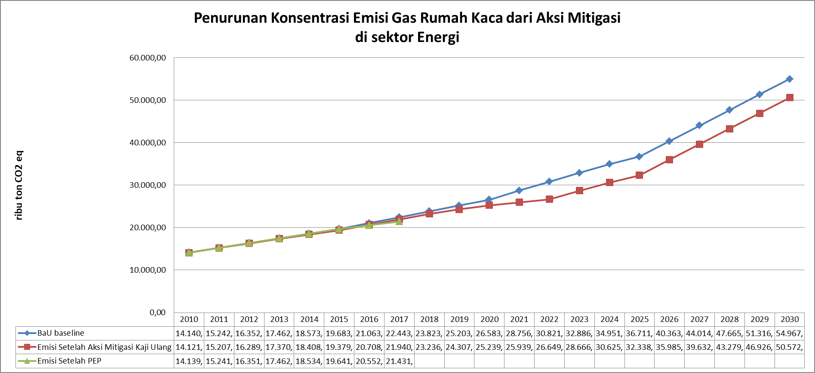

7,99%

Gambar Lampiran 3. 1. Penurunan Emisi GRK dari Aksi Mitigasi Sektor Energi

**LAMPIRAN 3.2. PREDIKSI PENURUNAN EMISI PADA SEKTOR TRANSPORTASI**

Tabel Lampiran 3. 11. Data Aktivitas dan Penurunan Emisi Aksi Mitigasi Jaringan Trayek Angkutan Umum di Metropolitan Bandung Raya



Tabel Lampiran 3. 12. Perhitungan Penurunan Emisi Aksi Mitigasi Jaringan Trayek Angkutan Umum di Metropolitan Bandung Raya (1)



Tabel Lampiran 3. 13. Perhitungan Penurunan Emisi Aksi Mitigasi Jaringan Trayek Angkutan Umum di Metropolitan Bandung Raya (2)



Tabel Lampiran 3. 14. Perhitungan Penurunan Emisi Aksi Mitigasi Jaringan Trayek Angkutan Umum di Metropolitan Bandung Raya (3)



Tabel Lampiran 3. 15. Perhitungan Penurunan Emisi Aksi Mitigasi Jaringan Trayek Angkutan Umum di Metropolitan Bandung Raya (4)



Tabel Lampiran 3. 16. Perhitungan Penurunan Emisi Aksi Mitigasi Jaringan Trayek Angkutan Massal dalam Masterplan BRT di   
Kota Bandung



Tabel Lampiran 3. 17. Perhitungan Penurunan Emisi Aksi Mitigasi pada Trayek Angkutan Umum AKDP di PKN Bodebek   
Kota Bandung



Tabel Lampiran 3. 18. Perhitungan Penurunan Emisi Aksi Mitigasi Car Free Day



Tabel Lampiran 3. 19. Pendugaan Konsentrasi Emisi GRK Sektor Transportasi



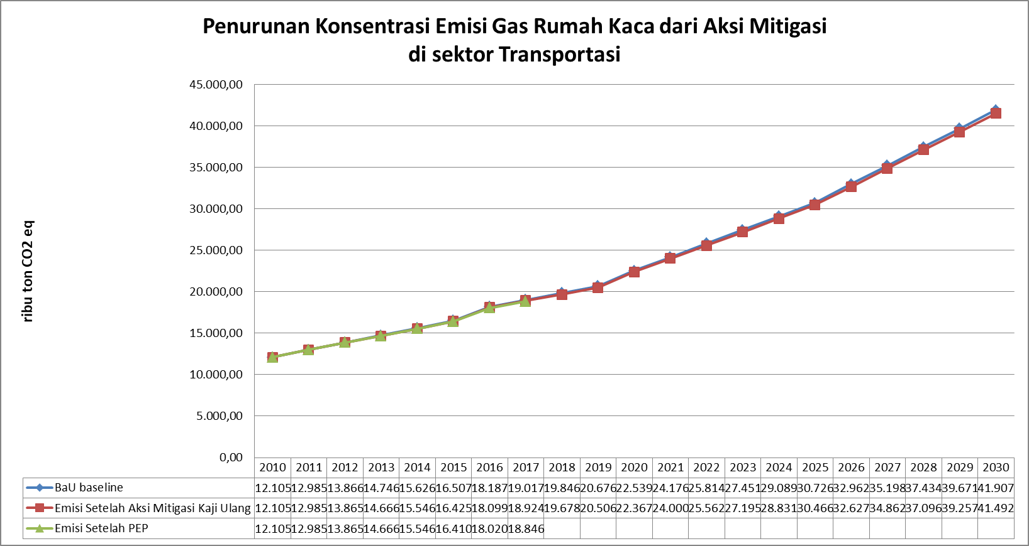

0,99%

Gambar Lampiran 3. 2. Penurunan Emisi GRK dari Aksi Mitigasi Sektor Transportasi

LAMPIRAN 4

PREDIKSI PENURUNAN EMISI PADA SEKTOR BERBASIS LIMBAH

Tabel Lampiran 4. 1. Komposting di TPK Sarimukti

| **Nama TPA** | **Tahun Operasional untuk Aksi Mitigasi** | **Luas (Ha)** | **Kapasitas Tampung Lanfill (ton/hari)** | **% sampah yang dikompos** | **Jumlah Jiwa Terlayani (jiwa)** | **Lokasi Pelayanan** | **Teknologi TPA** |
| --- | --- | --- | --- | --- | --- | --- | --- |
| TPK Sarimukti | 2017- 2023 | 25,2 | 1.800 | 10% | 2.2500.000 | Kota Bandung, Kota Cimahi, Kab. Bandung, Kab. Bandung Barat | *Controled Landfill* dengan teknologi pengolahan sampah “**Kompos**” |

**Tabel Lampiran 4. 2 Contoh Perhitungan penurunan emisi BRK dari peralihan pengelolaan sampah dari Landfill ke Kompoting (di TPA)**

**a. Perhitungan penurunan emisi CH4 dari peralihan pengelolaan sampah dari Landfill ke Kompoting (di TPA)**

|  |  |  |  |  |  |  |  |  |  |  |  |  |  |
| --- | --- | --- | --- | --- | --- | --- | --- | --- | --- | --- | --- | --- | --- |
| **a.1. Worksheet untuk input data aktivitas dan komposisi sampah** | | | | | | | | | | | | | |
|  | |  | **Composition of waste going to solid waste disposal sites** | | | | | | | | | | |  | |
| **Year** | | **Total Sampah yang dikompos *)** | **Sisa Makanan** | **Kertas** | **Nappies** | **Taman** | **kayu** | **Tekstil** | **Karet dan Kulit** | **All Other, inert waste** | | | | **Total** | |
| **Plastik** | **Logam** | **Kaca** | **Lain2 anorganik** |
|  | | Ton/tahun | % | % | % | % | % | % | % | % | % | % | % | (=100%) | |
| 2010 | | 65.700,0 | 60% | 0% | 0% | 40% | 0% | 0% | 0% | 0% | 0% | 0% | 0% | 100% | |
| 2011 | | 65.700,0 | 60% | 0% | 0% | 40% | 0% | 0% | 0% | 0% | 0% | 0% | 0% | 100% | |
| 2012 | | 65.700,0 | 60% | 0% | 0% | 40% | 0% | 0% | 0% | 0% | 0% | 0% | 0% | 100% | |
| 2013 | | 65.700,0 | 60% | 0% | 0% | 40% | 0% | 0% | 0% | 0% | 0% | 0% | 0% | 100% | |
| 2014 | | 65.700,0 | 60% | 0% | 0% | 40% | 0% | 0% | 0% | 0% | 0% | 0% | 0% | 100% | |
| 2015 | | 65.700,0 | 60% | 0% | 0% | 40% | 0% | 0% | 0% | 0% | 0% | 0% | 0% | 100% | |
| 2016 | | 65.700,0 | 60% | 0% | 0% | 40% | 0% | 0% | 0% | 0% | 0% | 0% | 0% | 100% | |
| 2017 | | 65.700,0 | 60% | 0% | 0% | 40% | 0% | 0% | 0% | 0% | 0% | 0% | 0% | 100% | |
| 2018 | | 65.700,0 | 60% | 0% | 0% | 40% | 0% | 0% | 0% | 0% | 0% | 0% | 0% | 100% | |
| 2019 | | 65.700,0 | 60% | 0% | 0% | 40% | 0% | 0% | 0% | 0% | 0% | 0% | 0% | 100% | |
| 2020 | | 65.700,0 | 60% | 0% | 0% | 40% | 0% | 0% | 0% | 0% | 0% | 0% | 0% | 100% | |
| 2021 | | 65.700 | 60% | 0% | 0% | 40% | 0% | 0% | 0% | 0% | 0% | 0% | 0% | 100% | |
| 2022 | | 65.700 | 60% | 0% | 0% | 40% | 0% | 0% | 0% | 0% | 0% | 0% | 0% | 100% | |
| 2023 | | 65.700 | 60% | 0% | 0% | 40% | 0% | 0% | 0% | 0% | 0% | 0% | 0% | 100% | |

*) **peralihan dari TPA Open dumping)**

**a.2. Worksheet Result penurunan emisi CH4**

|  |  |  |  |  |  |  |  |  |  |  |  |  |
| --- | --- | --- | --- | --- | --- | --- | --- | --- | --- | --- | --- | --- |
|  | **Methane generated** | | | | | | | | | | |  |
| **Year** | **Sisa Makanan** | **Kertas** | **Nappies** | **Taman** | **kayu** | **Tekstil** | **Sludge** | **Bulk MSW** | **Industrial** | **Total** | **Methane recovery** | **Methane emission** |
|  | A | B | C | D | E | F | G | H | I | K | L | M = (K-L)*(1-OX) |
|  | Ton | Ton | Ton | Ton | Ton | Ton | Ton | Ton | Ton | Ton | Ton | Ton CH4 |
| 2010 | 0 | 0 | 0 | 0 | 0 | 0 | 0 |  | 0 | 0 | 0 | 0,0000 |
| 2011 | 527 | 0 | 0 | 456 | 48 | 0 | 0 |  | 0 | 1.031 | 0 | 1.031,2941 |
| 2012 | 880 | 0 | 0 | 841 | 95 | 0 | 0 |  | 0 | 1.816 | 0 | 1.815,9262 |
| 2013 | 1.117 | 0 | 0 | 1.166 | 140 | 0 | 0 |  | 0 | 2.422 | 0 | 2.422,3601 |
| 2014 | 1.275 | 0 | 0 | 1.440 | 183 | 0 | 0 |  | 0 | 2.898 | 0 | 2.898,4385 |
| 2015 | 1.382 | 0 | 0 | 1.671 | 225 | 0 | 0 |  | 0 | 3.278 | 0 | 3.277,8787 |
| 2016 | 1.453 | 0 | 0 | 1.866 | 265 | 0 | 0 |  | 0 | 3.585 | 0 | 3.584,6737 |
| 2017 | 1.501 | 0 | 0 | 2.031 | 305 | 0 | 0 |  | 0 | 3.836 | 0 | 3.836,0828 |
| 2018 | 1.533 | 0 | 0 | 2.170 | 342 | 0 | 0 |  | 0 | 4.045 | 0 | 4.044,6690 |
| 2019 | 1.554 | 0 | 0 | 2.287 | 379 | 0 | 0 |  | 0 | 4.220 | 0 | 4.219,6942 |
| 2020 | 1.569 | 0 | 0 | 2.386 | 414 | 0 | 0 |  | 0 | 4.368 | 0 | 4.368,0775 |
| 2021 | 1.578 | 0 | 0 | 2.469 | 448 | 0 | 0 |  | 0 | 4.495 | 0 | 4.495,0583 |
| 2022 | 1.585 | 0 | 0 | 2.539 | 481 | 0 | 0 |  | 0 | 4.605 | 0 | 4.604,6575 |
| 2023 | 1.589 | 0 | 0 | 2.599 | 512 | 0 | 0 |  | 0 | 4.700 | 0 | 4.700,0015 |
| PENURUNAN EMISI METAN DI TAHUN 2023 (TON CO2 eq | | | | | | | | | | | | 98.700,03 |

**b. perhitungan emisi CH4 dari aktivitas Kompoting Itu Sendiri (di TPA)**

| **Tahun** | Jumlah sampah yang diolah secara biologi dlm satu tahun (Ton) | Faktor Emisi (g CH4/kg sampah terolah) | Gas Metana yang dihasilkan per tahun (Ton CH4) | Gas Metana yang di-recovery/di-flare per tahun | Gas Metana yang dihasilkan per tahun | CO2e per tahun |
| --- | --- | --- | --- | --- | --- | --- |
|  |  | (Ton CH4) | (Ton CH4) | (Ton CO2) |
|  |  | C= (A x B) x10-3 |  | E = (C - D) |  |
| 2010 | 0,00 | 4 | 0,00 | 0,00 | 0,0000 | 0,00 |
| 2011 | 0,00 | 4 | 0,00 | 0,00 | 0,0000 | 0,00 |
| 2012 | 0,00 | 4 | 0,00 | 0,00 | 0,0000 | 0,00 |
| 2013 | 0,00 | 4 | 0,00 | 0,00 | 0,0000 | 0,00 |
| 2014 | 0,00 | 4 | 0,00 | 0,00 | 0,0000 | 0,00 |
| 2015 | 0,00 | 4 | 0,00 | 0,00 | 0,0000 | 0,00 |
| 2016 | 0,00 | 4 | 0,00 | 0,00 | 0,0000 | 0,00 |
| 2017 | 65700,00 | 4 | 262,80 | 0,00 | 262,8000 | 6044,40 |
| 2018 | 65700,00 | 4 | 262,80 | 0,00 | 262,8000 | 6044,40 |
| 2019 | 65700,00 | 4 | 262,80 | 0,00 | 262,8000 | 6044,40 |
| 2020 | 65700,00 | 4 | 262,80 | 0,00 | 262,8000 | 6044,40 |
| 2021 | 65700,00 | 4 | 262,80 | 0,00 | 262,8000 | 6044,40 |
| 2022 | 65700,00 | 4 | 262,80 | 0,00 | 262,8000 | 6044,40 |
| 2023 | 65700,00 | 4 | 262,80 | 0,00 | 262,8000 | 6044,40 |
| 2024 | 0,00 | 4 | 0,00 | 0,00 | 0,0000 | 0,00 |
| 2025 | 0,00 | 4 | 0,00 | 0,00 | 0,0000 | 0,00 |
| 2026 | 0,00 | 4 | 0,00 | 0,00 | 0,0000 | 0,00 |
| 2027 | 0,00 | 4 | 0,00 | 0,00 | 0,0000 | 0,00 |
| 2028 | 0,00 | 4 | 0,00 | 0,00 | 0,0000 | 0,00 |
| 2029 | 0,00 | 4 | 0,00 | 0,00 | 0,0000 | 0,00 |
| 2030 | 0,00 | 4 | 0,00 | 0,00 | 0,0000 | 0,00 |
|  |  |  |  | Total Emisi | 1051,2000 | 42310,80 |

**c. perhitungan emisi NO2 dari aktivitas Kompoting Itu Sendiri (di TPA)**

| **Tahun** | Jumlah sampah yang diolah secara biologi dlm satu tahun | Emission Factor | Net Annual Nitrous Oxide Emissions | CO2e per tahun |
| --- | --- | --- | --- | --- |
| (Ton) | (g N2O/kg waste treated) | (RIBU Ton N2O) | (Ton CO2) |
| **Pengomposan - Limbah Padat Domestik** | | | |  |
| 2010 | 0,00 | 0,300 | 0,00000 | 0,00 |
| 2011 | 0,00 | 0,300 | 0,00000 | 0,00 |
| 2012 | 0,00 | 0,300 | 0,00000 | 0,00 |
| 2013 | 0,00 | 0,300 | 0,00000 | 0,00 |
| 2014 | 0,00 | 0,300 | 0,00000 | 0,00 |
| 2015 | 0,00 | 0,300 | 0,00000 | 0,00 |
| 2016 | 0,00 | 0,300 | 0,00000 | 0,00 |
| 2017 | 65700,00 | 0,300 | 19,71000 | 5873,58 |
| 2018 | 65700,00 | 0,300 | 19,71000 | 5873,58 |
| 2019 | 65700,00 | 0,300 | 19,71000 | 5873,58 |
| 2020 | 65700,00 | 0,300 | 19,71000 | 5873,58 |
| 2021 | 65700,00 | 0,300 | 19,71000 | 5873,58 |
| 2022 | 65700,00 | 0,300 | 19,71000 | 5873,58 |
| 2023 | 65700,00 | 0,300 | 19,71000 | 5873,58 |
| 2024 | 0,00 | 0,300 | 0,00000 | 0,00 |
| 2025 | 0,00 | 0,300 | 0,00000 | 0,00 |
| 2026 | 0,00 | 0,300 | 0,00000 | 0,00 |
| 2027 | 0,00 | 0,300 | 0,00000 | 0,00 |
| 2028 | 0,00 | 0,300 | 0,00000 | 0,00 |
| 2029 | 0,00 | 0,300 | 0,00000 | 0,00 |
| 2030 | 0,00 | 0,300 | 0,00000 | 0,00 |
|  |  | Total Emisi | 78,8 | 41115,06 |

**d. REKAPITULASI PENURUNAN EMISI DARI DARI LANDFILL KE KOMPOSTING (DI TPA)**

|  |  |  |  |
| --- | --- | --- | --- |
| **tahun** | **Penuruna emisi dari TPA** | **emisi dari komposting** | **Hasil Penurunan Emisi tahun 2030 (RIBU Ton CO2e)** |
|  |  |  |  |
| 2010 |  |  |  |
| 2011 |  |  |  |
| 2012 |  |  |  |
| 2013 |  |  |  |
| 2014 |  |  |  |
| 2015 |  |  |  |
| 2016 |  |  |  |
| 2017 |  |  |  |
| 2018 | 84.938,05 | 11917,98 | 73.020,07 |
| 2019 | 88.613,58 | 11917,98 | 76.695,60 |
| 2020 | 91.729,63 | 11917,98 | 79.811,65 |
| 2021 | 94.396,22 | 11917,98 | 82.478,24 |
| 2022 | 96.697,81 | 11917,98 | 84.779,83 |
| 2023 | 98.700,03 | 11917,98 | 86.782,05 |
| 2024 | 100.454,57 | 11917,98 | 88.536,59 |
| 2025 | 80.345,37 | 0,00 | 80.345,37 |
| 2026 | 65.242,61 | 0,00 | 65.242,61 |
| 2027 | 53.735,40 | 0,00 | 53.735,40 |
| 2028 | 44.841,02 | 0,00 | 44.841,02 |
| 2029 | 37.869,51 | 0,00 | 37.869,51 |
| 2030 | 32.332,05 | 0,00 | 32.332,05 |
| **Nilai Penurunan Emisi = Hasil perhitungan BAU - Nilai Emisi dari proses Komposting** | | | |

Tabel Lampiran 4. 3. TPST 3R di Jawa Barat

|  |  |  |  |  |  |  |
| --- | --- | --- | --- | --- | --- | --- |
| **Tahun** | **Jumlah Sampah Terkelola per Tahun (ton/tahun)** | **60% Sampah Dikompos (ton/tahun)** | **5% Daur ulang materlal kertas (ton/tahun) (sudah akumulasi)** | **Jumlah TPS 3R** | **Kapasitas TPS 3 R (m3/unit/ hari)** | **Indikasi pembiayaan (Ribu rupiah)** |
| **2010** | 1.095 | 657 | 60 | 5 | 3 | 2.750.000 |
| **2011** | 1.533 | 920 | 84 | 7 | 3 | 3.850.000 |
| **2012** | 1.095 | 657 | 60 | 5 | 3 | 2.750.000 |
| **2013** | 1.313 | 788 | 72 | 6 | 3 | 3.300.000 |
| **2014** | 1.533 | 920 | 84 | 7 | 3 | 3.850.000 |
| **2015** | 2.408 | 1.445 | 131 | 11 | 3 | 6.050.000 |
| **2016** | 5.257 | 3.154 | 287 | 24 | 3 | 13.200.000 |
| **2017** | 5.257 | 3.154 | 287 | 24 | 3 | 13.200.000 |
| **2018** | 5.257 | 3.154 | 287 | 24 | 3 | 13.200.000 |
| **2019** | 5.475 | 3.318 | 299 | 30 | 3 | 15.000.000 |
| **2020** | 7.300 | 4.424 | 398 | 40 | 3 | 2.142.960 |
| **2021** | 1.095 | 664 | 60 | 6 | 3 | 2.401.965 |
| **2022** | 913 | 553 | 50 | 5 | 3 | 1.993.980 |
| **2023** | 913 | 553 | 50 | 5 | 3 | 2.130.000 |
| **2024** | 548 | 332 | 30 | 3 | 3 | 1.200.000 |
| **2025** | 548 | 332 | 30 | 3 | 3 | 650.995 |
| **2026** | 548 | 332 | 30 | 3 | 3 | 650.995 |
| **2027** | 548 | 332 | 30 | 3 | 3 | 650.995 |
| **2028** | 548 | 332 | 30 | 3 | 3 | 650.995 |
| **2029** | 548 | 332 | 30 | 3 | 3 | 650.995 |
| **2030** | 548 | 332 | 30 | 3 | 3 | 650.995 |

**Tabel Lampiran 4. 4. Contoh Perhitungan penurunan emisi GRK aksi mitigasi Kompoting di TPS 3 R**

**a. perhitungan penurunan emisi CH4 dari peralihan pengelolaan sampah dari Landfill ke Kompoting (di TPS 3 R)**

**a.1. Worksheet untuk input data aktivitas dan komposisi sampah**

|  |  |  |  |  |  |  |  |  |  |  |  |  |
| --- | --- | --- | --- | --- | --- | --- | --- | --- | --- | --- | --- | --- |
|  |  | **Composition of waste going to solid waste disposal sites** | | | | | | | | | | |
| **Year** | **Total Sampah yang dikompos** | **Sisa Makanan** | **Kertas** | **Nappies** | **Taman** | **kayu** | **Tekstil** | **Karet dan Kulit** | **All Other, inert waste** | | | |
| **Plastik** | **Logam** | **Kaca** | **Lain2 anorganik** |
|  | Ton | % | % | % | % | % | % | % | % | % | % | % |
| 2010 | 657,0 | 60% | 0% | 0% | 40% | 0% | 0% | 0% | 0% | 0% | 0% | 0% |
| 2011 | 920,0 | 60% | 0% | 0% | 40% | 0% | 0% | 0% | 0% | 0% | 0% | 0% |
| 2012 | 657,0 | 60% | 0% | 0% | 40% | 0% | 0% | 0% | 0% | 0% | 0% | 0% |
| 2013 | 788,0 | 60% | 0% | 0% | 40% | 0% | 0% | 0% | 0% | 0% | 0% | 0% |
| 2014 | 920,0 | 60% | 0% | 0% | 40% | 0% | 0% | 0% | 0% | 0% | 0% | 0% |
| 2015 | 1.445,0 | 60% | 0% | 0% | 40% | 0% | 0% | 0% | 0% | 0% | 0% | 0% |
| 2016 | 3.154,0 | 60% | 0% | 0% | 40% | 0% | 0% | 0% | 0% | 0% | 0% | 0% |
| 2017 | 3.154,0 | 60% | 0% | 0% | 40% | 0% | 0% | 0% | 0% | 0% | 0% | 0% |
| 2018 | 3.154,0 | 60% | 0% | 0% | 40% | 0% | 0% | 0% | 0% | 0% | 0% | 0% |
| 2019 | 3.318,0 | 60% | 0% | 0% | 40% | 0% | 0% | 0% | 0% | 0% | 0% | 0% |
| 2020 | 4.424,0 | 60% | 0% | 0% | 40% | 0% | 0% | 0% | 0% | 0% | 0% | 0% |
| 2021 | 5.037 | 60% | 0% | 0% | 40% | 0% | 0% | 0% | 0% | 0% | 0% | 0% |
| 2022 | 5.585 | 60% | 0% | 0% | 40% | 0% | 0% | 0% | 0% | 0% | 0% | 0% |
| 2023 | 6.132 | 60% | 0% | 0% | 40% | 0% | 0% | 0% | 0% | 0% | 0% | 0% |
| 2024 | 6.461 | 60% | 0% | 0% | 40% | 0% | 0% | 0% | 0% | 0% | 0% | 0% |
| 2025 | 6.789 | 60% | 0% | 0% | 40% | 0% | 0% | 0% | 0% | 0% | 0% | 0% |
| 2026 | 7.118 | 60% | 0% | 0% | 40% | 0% | 0% | 0% | 0% | 0% | 0% | 0% |
| 2027 | 7.446 | 60% | 0% | 0% | 40% | 0% | 0% | 0% | 0% | 0% | 0% | 0% |
| 2028 | 7.775 | 60% | 0% | 0% | 40% | 0% | 0% | 0% | 0% | 0% | 0% | 0% |
| 2029 | 8.103 | 60% | 0% | 0% | 40% | 0% | 0% | 0% | 0% | 0% | 0% | 0% |
| 2030 | 8.432 | 60% | 0% | 0% | 40% | 0% | 0% | 0% | 0% | 0% | 0% | 0% |

**a.2. Worksheet Result penurunan emisi CH4**

| **Year** | **Methane generated** | | | | | | | | | | | Penurunan Emisi Metan | |
| --- | --- | --- | --- | --- | --- | --- | --- | --- | --- | --- | --- | --- | --- |
| **Sisa Maka-nan** | **Kertas** | **Nappies** | **Taman** | **kayu** | **Tekstil** | **Sludge** | **Bulk MSW** | **Industrial** | **Total** | **Methane recovery** | **Methane emission** | **Konversi ke ton CO2e** |
| A | B | C | D | E | F | G | H | I | K | L | M = (K-L)*(1-OX) |  |
| Ton | Ton | Ton | Ton | Ton | Ton | Ton | Ton | Ton | Ton | Ton | Ton CH4 | - |
| 2010 | 0 | 0 | 0 | 0 | 0 | 0 | 0 |  | 0 | 0 | 0 | 0,0000 | 216,57 |
| 2011 | 5 | 0 | 0 | 5 | 0 | 0 | 0 |  | 0 | 10 | 0 | 10,3129 | 468,04 |
| 2012 | 11 | 0 | 0 | 10 | 1 | 0 | 0 |  | 0 | 22 | 0 | 22,2876 | 574,65 |
| 2013 | 13 | 0 | 0 | 13 | 2 | 0 | 0 |  | 0 | 27 | 0 | 27,3645 | 702,83 |
| 2014 | 15 | 0 | 0 | 17 | 2 | 0 | 0 |  | 0 | 33 | 0 | 33,4683 | 847,92 |
| 2015 | 17 | 0 | 0 | 20 | 3 | 0 | 0 |  | 0 | 40 | 0 | 40,3774 | 1.135,78 |
| 2016 | 23 | 0 | 0 | 27 | 4 | 0 | 0 |  | 0 | 54 | 0 | 54,0850 | 1.923,01 |
| 2017 | 41 | 0 | 0 | 45 | 6 | 0 | 0 |  | 0 | 92 | 0 | 91,5720 | 2.528,51 |
| 2018 | 53 | 0 | 0 | 60 | 8 | 0 | 0 |  | 0 | 120 | 0 | 120,4052 | 3.001,68 |
| 2019 | 61 | 0 | 0 | 72 | 10 | 0 | 0 |  | 0 | 143 | 0 | 142,9370 | 3.431,28 |
| 2020 | 67 | 0 | 0 | 84 | 12 | 0 | 0 |  | 0 | 163 | 0 | 163,3944 | 4.139,51 |
| 2021 | 81 | 0 | 0 | 102 | 15 | 0 | 0 |  | 0 | 197 | 0 | 197,1197 | 4.897,87 |
| 2022 | 94 | 0 | 0 | 121 | 18 | 0 | 0 |  | 0 | 233 | 0 | 233,2321 | 5.675,92 |
| 2023 | 108 | 0 | 0 | 141 | 22 | 0 | 0 |  | 0 | 270 | 0 | 270,2820 | 6.471,96 |
| 2024 | 122 | 0 | 0 | 161 | 25 | 0 | 0 |  | 0 | 308 | 0 | 308,1886 | 7.212,13 |
| 2025 | 133 | 0 | 0 | 181 | 29 | 0 | 0 |  | 0 | 343 | 0 | 343,4347 | 7.912,12 |
| 2026 | 144 | 0 | 0 | 200 | 33 | 0 | 0 |  | 0 | 377 | 0 | 376,7676 | 8.582,97 |
| 2027 | 153 | 0 | 0 | 218 | 37 | 0 | 0 |  | 0 | 409 | 0 | 408,7128 | 9.232,50 |
| 2028 | 163 | 0 | 0 | 236 | 41 | 0 | 0 |  | 0 | 440 | 0 | 439,6426 | 9.866,30 |
| 2029 | 171 | 0 | 0 | 253 | 46 | 0 | 0 |  | 0 | 470 | 0 | 469,8239 | 10.488,44 |
| 2030 | 180 | 0 | 0 | 270 | 50 | 0 | 0 |  | 0 | 499 | 0 | 499,4496 | 11.101,88 |

**b. perhitungan emisi CH4 dari aktivitas Kompoting Itu Sendiri (di TPS 3 R)**

|  |  |  |  |  |  |  |
| --- | --- | --- | --- | --- | --- | --- |
| **Tahun** | Jumlah sampah yang diolah secara biologi dlm satu tahun (Ton) | Faktor Emisi (g CH4/kg sampah terolah) | Gas Metana yang dihasilkan per tahun (Ton CH4) | Gas Metana yang di-recovery/di-flare per tahun | Gas Metana yang dihasilkan per tahun | CO2e per tahun |
| (Ton CH4) | (Ton CH4) | (Ton CO2) |
| 2010 | 657,00 | 4 | 2,63 | 0,00 | 2,6280 | 60,44 |
| 2011 | 920,00 | 4 | 3,68 | 0,00 | 3,6800 | 84,64 |
| 2012 | 657,00 | 4 | 2,63 | 0,00 | 2,6280 | 60,44 |
| 2013 | 788,00 | 4 | 3,15 | 0,00 | 3,1520 | 72,50 |
| 2014 | 920,00 | 4 | 3,68 | 0,00 | 3,6800 | 84,64 |
| 2015 | 1445,00 | 4 | 5,78 | 0,00 | 5,7800 | 132,94 |
| 2016 | 3154,00 | 4 | 12,62 | 0,00 | 12,6160 | 290,17 |
| 2017 | 3154,00 | 4 | 12,62 | 0,00 | 12,6160 | 290,17 |
| 2018 | 3154,00 | 4 | 12,62 | 0,00 | 12,6160 | 290,17 |
| 2019 | 3318,00 | 4 | 13,27 | 0,00 | 13,2720 | 305,26 |
| 2020 | 4424,00 | 4 | 17,70 | 0,00 | 17,6960 | 407,01 |
| 2021 | 5037,00 | 4 | 20,15 | 0,00 | 20,1480 | 463,40 |
| 2022 | 5584,50 | 4 | 22,34 | 0,00 | 22,3380 | 513,77 |
| 2023 | 6132,00 | 4 | 24,53 | 0,00 | 24,5280 | 564,14 |
| 2024 | 6460,50 | 4 | 25,84 | 0,00 | 25,8420 | 594,37 |
| 2025 | 6789,00 | 4 | 27,16 | 0,00 | 27,1560 | 624,59 |
| 2026 | 7117,50 | 4 | 28,47 | 0,00 | 28,4700 | 654,81 |
| 2027 | 7446,00 | 4 | 29,78 | 0,00 | 29,7840 | 685,03 |
| 2028 | 7774,50 | 4 | 31,10 | 0,00 | 31,0980 | 715,25 |
| 2029 | 8103,00 | 4 | 32,41 | 0,00 | 32,4120 | 745,48 |
| 2030 | 8431,50 | 4 | 33,73 | 0,00 | 33,7260 | 775,70 |
|  |  |  |  | Total Emisi | 90,3640 | 8414,92 |

**c. perhitungan emisi NO2 dari aktivitas Kompoting Itu Sendiri (di TPS 3 R)**

|  |  |  |  |  |
| --- | --- | --- | --- | --- |
| **Tahun** | Jumlah sampah yang diolah secara biologi dlm satu tahun | Emission Factor | Net Annual Nitrous Oxide Emissions | CO2e per tahun |
| 2010 | 657,00 | 0,300 | 0,19710 | 58,74 |
| 2011 | 920,00 | 0,300 | 0,27600 | 82,25 |
| 2012 | 657,00 | 0,300 | 0,19710 | 58,74 |
| 2013 | 788,00 | 0,300 | 0,23640 | 70,45 |
| 2014 | 920,00 | 0,300 | 0,27600 | 82,25 |
| 2015 | 1445,00 | 0,300 | 0,43350 | 129,18 |
| 2016 | 3154,00 | 0,300 | 0,94620 | 281,97 |
| 2017 | 3154,00 | 0,300 | 0,94620 | 281,97 |
| 2018 | 3154,00 | 0,300 | 0,94620 | 281,97 |
| 2019 | 3318,00 | 0,300 | 0,99540 | 296,63 |
| 2020 | 4424,00 | 0,300 | 1,32720 | 395,51 |
| 2021 | 5037,00 | 0,300 | 1,51110 | 450,31 |
| 2022 | 5584,50 | 0,300 | 1,67535 | 499,25 |
| 2023 | 6132,00 | 0,300 | 1,83960 | 548,20 |
| 2024 | 6460,50 | 0,300 | 1,93815 | 577,57 |
| 2025 | 6789,00 | 0,300 | 2,03670 | 606,94 |
| 2026 | 7117,50 | 0,300 | 2,13525 | 636,30 |
| 2027 | 7446,00 | 0,300 | 2,23380 | 665,67 |
| 2028 | 7774,50 | 0,300 | 2,33235 | 695,04 |
| 2029 | 8103,00 | 0,300 | 2,43090 | 724,41 |
| 2030 | 8431,50 | 0,300 | 2,52945 | 753,78 |
|  |  | Total Emisi | 6,8 | 8177,11 |

**d. REKAPITULASI PENURUNAN EMISI DARI DARI LANDFILL KE KOMPOTING (DI TPS 3 R)**

|  |  |  |  |  |
| --- | --- | --- | --- | --- |
| **Tahun** | **BaU** | **Akumulasi Emisi CH4 komposting** | **Emisi N2O komposting** | **Hasil Penurunan Emisi tahun 2030(Ton CO2e)** |
| 2010 | - | 60,44 | 58,74 | (119,18) |
| 2011 | 216,57 | 84,64 | 82,25 | 49,68 |
| 2012 | 468,04 | 60,44 | 58,74 | 348,86 |
| 2013 | 574,65 | 72,50 | 70,45 | 431,71 |
| 2014 | 702,83 | 84,64 | 82,25 | 535,95 |
| 2015 | 847,92 | 132,94 | 129,18 | 585,80 |
| 2016 | 1.135,78 | 290,17 | 281,97 | 563,65 |
| 2017 | 1.923,01 | 290,17 | 281,97 | 1.350,88 |
| 2018 | 2.528,51 | 290,17 | 281,97 | 1.956,37 |
| 2019 | 3.001,68 | 305,26 | 296,63 | 2.399,79 |
| 2020 | 3.431,28 | 407,01 | 395,51 | 2.628,77 |
| 2021 | 4.139,51 | 463,40 | 450,31 | 3.225,80 |
| 2022 | 4.897,87 | 513,77 | 499,25 | 3.884,85 |
| 2023 | 5.675,92 | 564,14 | 548,20 | 4.563,58 |
| 2024 | 6.471,96 | 594,37 | 577,57 | 5.300,03 |
| 2025 | 7.212,13 | 624,59 | 606,94 | 5.980,60 |
| 2026 | 7.912,12 | 654,81 | 636,30 | 6.621,01 |
| 2027 | 8.582,97 | 685,03 | 665,67 | 7.232,26 |
| 2028 | 9.232,50 | 715,25 | 695,04 | 7.822,20 |
| 2029 | 9.866,30 | 745,48 | 724,41 | 8.396,42 |
| 2030 | 10.488,44 | 775,70 | 753,78 | 8.958,97 |
| Keterangan : Nilai Penurunan Emisi = Hasil perhitungan BAU - Nilai Emisi dari proses Komposting | | | | |

Tabel Lampiran 4. 5. Pengolahan Thermal di TPPAS di Jawa Barat

| **Nama TPA** | **Tahun Opera-sional** | **Luas (Ha)** | **Kapasitas Tampung (ton/hari)** | **Teknologi TPA** | **Jumlah Jiwa Terlayani (jiwa)** | **Indikasi Pembiayaan (ribu rupiah)** | **Lokasi Pelayanan** |
| --- | --- | --- | --- | --- | --- | --- | --- |
| TPPAS Regional Lulut Nambo | 2020 | 55 | 1.650 | 50% *Sanitary Landfill*,  50% dengan teknologi pengolahan sampah “***Refused Delivered Fuel (RDF)”*** | 2.062.500 | 800.000.000 | Kota Bogor, Kota Depok dan Kab. Bogor |
| TPPAS Regional Legok Nangka | 2021 | 78,1 | 1.800 | 50% *Sanitary landfill*  50% dengan teknologi pengolahan sampah **“PLTSA/ Waste to Energy”** | 2.250.000 | 3.500.000.000 | Kota Bandung, Kota Cimahi, Kab. Bandung, Kab. Bandung Barat, Kab. Sumedang, Kab. Garut |
| TPPAS Regional Ciayumaja kuning | 2023 | 60 | 1.000 | 50% *Sanitary Landfill*  50% dengan teknologi pengolahan sampah ***“Refused Delivered Fuel (RDF)”*** | 1.250.000 | - | Kota Cirebon, Kab. Cirebon dan Kab. Indramayu |
| TPPAS Regional Bekarpur | 2025 | 60 | 2.000 | 50% *Sanitary landfill*  50% dengan teknologi pengolahan sampah **“PLTSA/ Waste”** | 2.500.000 | - | Kota Bekasi, Kab. Bekasi, Kab. Karawang, Kab. Purwakarta |

**a. Perhitungan penurunan emisi CH4 dari peralihan pengelolaan sampah dari Landfill ke Kompoting (di TPS 3 R)**

**a.1. contoh Perhitungan penurunan emisi CH4 dari peralihan pengelolaan sampah dari Landfill ke Pengolahan Thermal**

**Tabel Lampiran 4. 6. Contoh Perhitungan penurunan emisi CH4 dari peralihan pengelolaan sampah dari Landfill ke Pengolahan Thermal**

**a. Perhitungan penurunan emisi CH4 dari peralihan pengelolaan sampah dari Landfill ke Pengolahan Thermal (PLTSa atau RDF)**

|  |  |  |  |  |  |  |  |  |  |  |  |  |  |  |
| --- | --- | --- | --- | --- | --- | --- | --- | --- | --- | --- | --- | --- | --- | --- |
| **a.1. Contoh Worksheet Memasukkan data berat dan komposisi sampah (contoh di bawah ini untuk penurunan emisi tahun 2020)** | | | | | | | | | | | | | | |
| **Year** | **Total Sampah yang dikompos (peralihan dari TPA Open dumping)** | | **Sisa Makan-an** | **Kertas** | **Nap-pies** | **Ta-man** | **kayu** | **Tek-stil** | **Karet dan Kulit** | **All Other, inert waste** | | | | **Total** |
| **Plastik** | **Logam** | **Kaca** | **Lain2 anorganik** |
|  | ton/hari | Ton/tahun | % | % | % | % | % | % | % | % | % | % | % | (=100%) |
| 2010 | 1650 | 602.250,0 | 60% | 0% | 0% | 40% | 0% | 0% | 0% | 0% | 0% | 0% | 0% | 100% |
| 2011 | 1651 | 602.615,0 | 60% | 0% | 0% | 40% | 0% | 0% | 0% | 0% | 0% | 0% | 0% | 100% |
| 2012 | 1652 | 602.980,0 | 60% | 0% | 0% | 40% | 0% | 0% | 0% | 0% | 0% | 0% | 0% | 100% |
| 2013 | 1653 | 603.345,0 | 60% | 0% | 0% | 40% | 0% | 0% | 0% | 0% | 0% | 0% | 0% | 100% |
| 2014 | 1654 | 603.710,0 | 60% | 0% | 0% | 40% | 0% | 0% | 0% | 0% | 0% | 0% | 0% | 100% |
| 2015 | 1655 | 604.075,0 | 60% | 0% | 0% | 40% | 0% | 0% | 0% | 0% | 0% | 0% | 0% | 100% |
| 2016 | 1656 | 604.440,0 | 60% | 0% | 0% | 40% | 0% | 0% | 0% | 0% | 0% | 0% | 0% | 100% |
| 2017 | 1657 | 604.805,0 | 60% | 0% | 0% | 40% | 0% | 0% | 0% | 0% | 0% | 0% | 0% | 100% |
| 2018 | 1658 | 605.170,0 | 60% | 0% | 0% | 40% | 0% | 0% | 0% | 0% | 0% | 0% | 0% | 100% |
| 2019 | 1659 | 605.535,0 | 60% | 0% | 0% | 40% | 0% | 0% | 0% | 0% | 0% | 0% | 0% | 100% |
| 2020 | 1660 | 605.900,0 | 60% | 0% | 0% | 40% | 0% | 0% | 0% | 0% | 0% | 0% | 0% | 100% |

**a.2. Contoh Worksheet hasil (contoh di bawah ini untuk penurunan emisi tahun 2020)**

|  |  |  |  |  |  |  |  |  |  |  |  |  |
| --- | --- | --- | --- | --- | --- | --- | --- | --- | --- | --- | --- | --- |
| **Year** | **Sisa Makanan** | **Kertas** | **Nappies** | **Taman** | **kayu** | **Tekstil** | **Sludge** | **Bulk MSW** | **Industrial** | **Total** | **Methane recovery** | **Methane emission** |
| A | B | C | D | E | F | G | H | I | K | L | M = (K-L)*(1-OX) |
| Ton | Ton | Ton | Ton | Ton | Ton | Ton | Ton | Ton | Ton | Ton | Ton |
| 2010 | 0 | 0 | 0 | 0 | 0 | 0 | 0 |  | 0 | 0 | 0 | 0 |
| 2011 | 4.829 | 0 | 0 | 4.183 | 442 | 0 | 0 |  | 0 | 9.454 | 0 | 9.454 |
| 2012 | 8.068 | 0 | 0 | 7.714 | 869 | 0 | 0 |  | 0 | 16.652 | 0 | 16.652 |
| 2013 | 10.243 | 0 | 0 | 10.696 | 1.281 | 0 | 0 |  | 0 | 22.221 | 0 | 22.221 |
| 2014 | 11.704 | 0 | 0 | 13.215 | 1.680 | 0 | 0 |  | 0 | 26.598 | 0 | 26.598 |
| 2015 | 12.686 | 0 | 0 | 15.342 | 2.065 | 0 | 0 |  | 0 | 30.093 | 0 | 30.093 |
| 2016 | 13.347 | 0 | 0 | 17.139 | 2.437 | 0 | 0 |  | 0 | 32.923 | 0 | 32.923 |
| 2017 | 13.793 | 0 | 0 | 18.658 | 2.797 | 0 | 0 |  | 0 | 35.248 | 0 | 35.248 |
| 2018 | 14.095 | 0 | 0 | 19.941 | 3.145 | 0 | 0 |  | 0 | 37.181 | 0 | 37.181 |
| 2019 | 14.300 | 0 | 0 | 21.027 | 3.481 | 0 | 0 |  | 0 | 38.808 | 0 | 38.808 |
| 2020 | 14.441 | 0 | 0 | 21.945 | 3.805 | 0 | 0 |  | 0 | 40.191 | 0 | 40.191 |
| PENURUNAN EMISI DI TAHUN 2020 (TON CO2 eq | | | | | | | | | | | | 840.855 |

**a.2. Resume Penurunan emisi CH4 dari peralihan pengelolaan sampah dari Landfill ke Pengolahan Thermal**

|  |  |  |  |  |
| --- | --- | --- | --- | --- |
| tahun | vol sampah (ton/hari) | emisi CH4 | akumulasi CH4  ton CH4 | Konversi ke satuan  ton CO2 eq |
| 2.020 | 1.650 | 40.041 | 40.041 | 840.855 |
| 2.021 | 1.800 | 44.951 | 84.991 | 1.784.817 |
| 2.022 |  |  | 84.991 | 1.784.817 |
| 2.023 | 1.000 | 26.111 | 111.102 | 2.333.151 |
| 2.024 |  |  | 111.102 | 2.333.151 |
| 2.025 | 2.000 | 53.970 | 165.072 | 3.466.512 |
| 2.026 |  |  | 165.072 | 3.466.512 |
| 2.027 |  |  | 165.072 | 3.466.512 |
| 2.028 |  |  | 165.072 | 3.466.512 |
| 2.029 |  |  | 165.072 | 3.466.512 |
| 2.030 |  |  | 165.072 | 3.466.512 |

1. **Perhitungan emisi CH4 dari aktivitas Pengolahan Thermal Itu Sendiri (Insinerasi)**

|  |  |  |  |  |
| --- | --- | --- | --- | --- |
| **Sector** | **Waste** | | |  |
| **Category** | **Incineration and Open Burning of Waste** | | |  |
| **Category Code** | **4C1** | | |  |
| **Sheet** | **I of I Estimation of CH4 emissions from Incineration of Waste** | | |  |
| **Type of Waste** | Amount of Waste Incinerated  (Wet Weight) 1  (ton/tahun ) | Methane Emission Factor  (kg CH4/Gg Wet Waste) | Methane Emissions  (ton CH4) | CO2 emissions  (ton/tahun ) |
|  |
| 2010 | 0 | 237 | 0,000 | 0 |
| 2011 | 0 | 237 | 0,000 | 0 |
| 2012 | 0 | 237 | 0,000 | 0 |
| 2013 | 0 | 237 | 0,000 | 0 |
| 2014 | 0 | 237 | 0,000 | 0 |
| 2015 | 0 | 237 | 0,000 | 0 |
| 2016 | 0 | 237 | 0,000 | 0 |
| 2017 | 0 | 237 | 0,000 | 0 |
| 2018 | 0 | 237 | 0,000 | 0 |
| 2019 | 0 | 237 | 0,000 | 0 |
| 2020 | 301125 | 237 | 71,367 | 1498,699125 |
| 2021 | 629625 | 237 | 149,221 | 3133,643625 |
| 2022 | 629625 | 237 | 149,221 | 3133,643625 |
| 2023 | 812125 | 237 | 192,474 | 4041,946125 |
| 2024 | 812125 | 237 | 192,474 | 4041,946125 |
| 2025 | 1177125 | 237 | 278,979 | 5858,551125 |
| 2026 | 1177125 | 237 | 278,979 | 5858,551125 |
| 2027 | 1177125 | 237 | 278,979 | 5858,551125 |
| 2028 | 1177125 | 237 | 278,979 | 5858,551125 |
| 2029 | 1177125 | 237 | 278,979 | 5858,551125 |
| 2030 | 1177125 | 237 | 278,979 | 5858,551125 |

1. **Perhitungan emisi NO2 dari aktivitas Pengolahan Thermal Itu Sendiri (Insinerasi)**

|  |  |  |  |  |
| --- | --- | --- | --- | --- |
| **Sector** | **Waste** | | |  |
| **Category** | **Incineration and Open Burning of Waste** | | |  |
| **Category Code** | **4C1** | | |  |
| **Sheet** | **I of I Estimation of N2O emissions from Incineration of Waste** | | |  |
| **YEAR** | Total Amount of Waste Incinerated (Wet Weight 1)  (ton Waste) | Nitrous Oxide Emission Factor  (kg N2O/Gg Wet Waste) 1 | Nitrous Oxide Emissions  (ton N2O) | CO2 emissions (ton CO2e) |
|  | 0,000 | 221 | 0,000 |  |
| 2010 | 0,0 | 221 | 0,000 | 0 |
| 2011 | 0,0 | 221 | 0,000 | 0 |
| 2012 | 0,0 | 221 | 0,000 | 0 |
| 2013 | 0,0 | 221 | 0,000 | 0 |
| 2014 | 0,0 | 221 | 0,000 | 0 |
| 2015 | 0,0 | 221 | 0,000 | 0 |
| 2016 | 0,0 | 221 | 0,000 | 0 |
| 2017 | 0,0 | 221 | 0,000 | 0 |
| 2018 | 0,0 | 221 | 0,000 | 0 |
| 2019 | 0,0 | 221 | 0,000 | 0 |
| 2020 | 301.125,0 | 221 | 66,549 | 19.831,49 |
| 2021 | 629.625,0 | 221 | 139,147 | 41.465,8 |
| 2022 | 629.625,0 | 221 | 139,147 | 41.465,8 |
| 2023 | 812.125,0 | 221 | 179,480 | 53.484,9 |
| 2024 | 812.125,0 | 221 | 179,480 | 53.484,9 |
| 2025 | 1.177.125,0 | 221 | 260,145 | 77.523,1 |
| 2026 | 1.177.125,0 | 221 | 260,145 | 77.523,1 |
| 2027 | 1.177.125,0 | 221 | 260,145 | 77.523,1 |
| 2028 | 1.177.125,0 | 221 | 260,145 | 77.523,1 |
| 2029 | 1.177.125,0 | 221 | 260,145 | 77.523,1 |
| 2030 | 1.177.125,0 | 221 | 260,145 | 77.523,1 |

**d. REKAPITULASI PENURUNAN EMISI DARI DARI LANDFILL KE PENGOLAHAN THERMAL**

| **tahun** | **Emisi dari insienerasi (AKUMULASI) (ton CO2 eq)** | **Emisi jika dIkelola di TPA (AKUMULASI) ( ton CO2 eq)** | **PENURUNAN EMISI DARI PLTSa (ribu ton CO2 eq)** |
| --- | --- | --- | --- |
| 2010 | 0,0 | 0,0 | 0,0 |
| 2011 | 0,0 | 0,0 | 0,0 |
| 2012 | 0,0 | 0,0 | 0,0 |
| 2013 | 0,0 | 0,0 | 0,0 |
| 2014 | 0,0 | 0,0 | 0,0 |
| 2015 | 0,0 | 0,0 | 0,0 |
| 2016 | 0,0 | 0,0 | 0,0 |
| 2017 | 0,0 | 0,0 | 0,0 |
| 2018 | 0,0 | 0,0 | 0,0 |
| 2019 | 0,0 | 0,0 | 0,0 |
| 2020 | 34.227,0 | 840.854,9 | 806.627,9 |
| 2021 | 71.565,5 | 1.784.817,2 | 1.713.251,6 |
| 2022 | 71.565,5 | 1.784.817,2 | 1.713.251,6 |
| 2023 | 92.309,1 | 2.333.150,7 | 2.240.841,5 |
| 2024 | 92.309,1 | 2.333.150,7 | 2.240.841,5 |
| 2025 | 133.796,4 | 3.466.512,3 | 3.332.715,9 |
| 2026 | 133.796,4 | 3.466.512,3 | 3.332.715,9 |
| 2027 | 133.796,4 | 3.466.512,3 | 3.332.715,9 |
| 2028 | 133.796,4 | 3.466.512,3 | 3.332.715,9 |
| 2029 | 133.796,4 | 3.466.512,3 | 3.332.715,9 |
| 2030 | 133.796,4 | 3.466.512,3 | 3.332.715,9 |
| Keterangan : Nilai Penurunan Emisi = Hasil perhitungan BAU - Nilai Emisi dari proses Thermal | | | |

|  |  |  |  |  |  |  |  |  |  |  |  |  |  |  |
| --- | --- | --- | --- | --- | --- | --- | --- | --- | --- | --- | --- | --- | --- | --- |
| **Tabel Lampiran 4. 7. Contoh Perhitungan penurunan emisi CH4 dari peralihan pengelolaan sampah dari Landfill ke Komposting (di TPA)**   1. **Contoh Worksheet Memasukkan data berat dan komposisi sampah (untuk penurunan emisi tahun 2020)** | | | | | | | | | | | | | | |
|  |  | **Composition of waste going to solid waste disposal sites** | | | | | | | | | | |  | |
| **Year** | **Total Sampah yang dikompos (peralihan dari TPA Open dumping)** | **Sisa Makanan** | **Ker-tas** | **Nap-pies** | **Ta-man** | **kayu** | **Teks-til** | **Karet dan Kulit** | **All Other, inert waste** | | | | **Total** | |
| **Plastik** | **Logam** | **Kaca** | **Lain2 anorganik** |
|  | Ton/thun | % | % | % | % | % | % | % | % | % | % | % | (=100%) | |
| 2010 | 65.700,0 | 60% | 0% | 0% | 40% | 0% | 0% | 0% | 0% | 0% | 0% | 0% | 100% | |
| 2011 | 65.700,0 | 60% | 0% | 0% | 40% | 0% | 0% | 0% | 0% | 0% | 0% | 0% | 100% | |
| 2012 | 65.700,0 | 60% | 0% | 0% | 40% | 0% | 0% | 0% | 0% | 0% | 0% | 0% | 100% | |
| 2013 | 65.700,0 | 60% | 0% | 0% | 40% | 0% | 0% | 0% | 0% | 0% | 0% | 0% | 100% | |
| 2014 | 65.700,0 | 60% | 0% | 0% | 40% | 0% | 0% | 0% | 0% | 0% | 0% | 0% | 100% | |
| 2015 | 65.700,0 | 60% | 0% | 0% | 40% | 0% | 0% | 0% | 0% | 0% | 0% | 0% | 100% | |
| 2016 | 65.700,0 | 60% | 0% | 0% | 40% | 0% | 0% | 0% | 0% | 0% | 0% | 0% | 100% | |
| 2017 | 65.700,0 | 60% | 0% | 0% | 40% | 0% | 0% | 0% | 0% | 0% | 0% | 0% | 100% | |
| 2018 | 65.700,0 | 60% | 0% | 0% | 40% | 0% | 0% | 0% | 0% | 0% | 0% | 0% | 100% | |
| 2019 | 65.700,0 | 60% | 0% | 0% | 40% | 0% | 0% | 0% | 0% | 0% | 0% | 0% | 100% | |
| 2020 | 65.700,0 | 60% | 0% | 0% | 40% | 0% | 0% | 0% | 0% | 0% | 0% | 0% | 100% | |
| 2021 | 65.700 | 60% | 0% | 0% | 40% | 0% | 0% | 0% | 0% | 0% | 0% | 0% | 100% | |
| 2022 | 65.700 | 60% | 0% | 0% | 40% | 0% | 0% | 0% | 0% | 0% | 0% | 0% | 100% | |
| 2023 | 65.700 | 60% | 0% | 0% | 40% | 0% | 0% | 0% | 0% | 0% | 0% | 0% | 100% | |

1. Tabel 2. Contoh Worksheet hasil (untuk penurunan emisi tahun 2023)

|  |  |  |  |  |  |  |  |  |  |  |  |  |
| --- | --- | --- | --- | --- | --- | --- | --- | --- | --- | --- | --- | --- |
|  | **Methane generated** | | | | | | | | | | |  |
| **Year** | **Sisa Makanan** | **Kertas** | **Nappies** | **Taman** | **kayu** | **Tekstil** | **Sludge** | **Bulk MSW** | **Industrial** | **Total** | **Methane recovery** | **Methane emission** |
|  | A | B | C | D | E | F | G | H | I | K | L | M = (K-L)*(1-OX) |
|  | Ton | Ton | Ton | Ton | Ton | Ton | Ton | Ton | Ton | Ton | Ton | Ton CH4 |
| 2010 | 0 | 0 | 0 | 0 | 0 | 0 | 0 |  | 0 | 0 | 0 | 0,0000 |
| 2011 | 527 | 0 | 0 | 456 | 48 | 0 | 0 |  | 0 | 1.031 | 0 | 1.031,2941 |
| 2012 | 880 | 0 | 0 | 841 | 95 | 0 | 0 |  | 0 | 1.816 | 0 | 1.815,9262 |
| 2013 | 1.117 | 0 | 0 | 1.166 | 140 | 0 | 0 |  | 0 | 2.422 | 0 | 2.422,3601 |
| 2014 | 1.275 | 0 | 0 | 1.440 | 183 | 0 | 0 |  | 0 | 2.898 | 0 | 2.898,4385 |
| 2015 | 1.382 | 0 | 0 | 1.671 | 225 | 0 | 0 |  | 0 | 3.278 | 0 | 3.277,8787 |
| 2016 | 1.453 | 0 | 0 | 1.866 | 265 | 0 | 0 |  | 0 | 3.585 | 0 | 3.584,6737 |
| 2017 | 1.501 | 0 | 0 | 2.031 | 305 | 0 | 0 |  | 0 | 3.836 | 0 | 3.836,0828 |
| 2018 | 1.533 | 0 | 0 | 2.170 | 342 | 0 | 0 |  | 0 | 4.045 | 0 | 4.044,6690 |
| 2019 | 1.554 | 0 | 0 | 2.287 | 379 | 0 | 0 |  | 0 | 4.220 | 0 | 4.219,6942 |
| 2020 | 1.569 | 0 | 0 | 2.386 | 414 | 0 | 0 |  | 0 | 4.368 | 0 | 4.368,0775 |
| 2021 | 1.578 | 0 | 0 | 2.469 | 448 | 0 | 0 |  | 0 | 4.495 | 0 | 4.495,0583 |
| 2022 | 1.585 | 0 | 0 | 2.539 | 481 | 0 | 0 |  | 0 | 4.605 | 0 | 4.604,6575 |
| 2023 | 1.589 | 0 | 0 | 2.599 | 512 | 0 | 0 |  | 0 | 4.700 | 0 | 4.700,0015 |
| PENURUNAN EMISI DI TAHUN 2023 (TON CO2 eq | | | | | | | | | | | | 98.700,03 |

Tabel Lampiran 4. 8. Pembangunan Fasilitas Pengolahan Air Limbah Secara Terpusat Aerobik

|  |  |  |  |  |
| --- | --- | --- | --- | --- |
| **Tahun** | **Jumlah jiwa terlayani (jiwa)** | **Indikasi pembiayaan (Ribu rupiah)** | **Nama IPAL & Lokasi pelayanan** | **Teknologi IPAL** |
| 2022 | 63.610 | 35.000 | IPAL Bojong Soang  Area pelayanan : Kota Bandung dan Kabupaten Bandung | IPAL Semi Aereob |

**Perhitungan penurunan emisi CH 4 dari Peralihan pengolahan Aanerobik ke Aerobik**



Tabel Lampiran 4. 3. Rekapitulasi Penurunan Emisi GRK Sektor Limbah

|  |  |  |  |  |  |  |  |  |  |
| --- | --- | --- | --- | --- | --- | --- | --- | --- | --- |
| **Tahun** | **BaU Baseline** | **Pembangunan Fasilitas Pengolahan Air Limbah Secara Terpusat (off site) aerobik**  **(ton CO2 eq)** | **Komposting di TPA**  **(ton CO2 eq)** | **Pengolahan Thermal**  **(ton CO2 eq)** | **Rencana Pembangunan dan Operasional TPS Terpadu 3R/Komposting** | | **Jumlah Penurunan Emisi** | | **Emisi Setelah Pelaksanaan Aksi Mitigasi** |
| **Daur Ulang Kertas**  **(ton CO2 eq)** | **Komposting**  **(ton CO2 eq)** | **(ton CO2 eq)** | **(Ribu ton CO2 eq)** |
| 2010 | 4.323.800 | 0 | 0 | 0,0 | 0,0 | 49,7 | 49,7 | 0,05 | 4.323.750,3 |
| 2011 | 5.573.500 | 0 | 0 | 0,0 | 21,5 | 49,7 | 71,2 | 0,07 | 5.573.428,8 |
| 2012 | 6.525.000 | 0 | 0 | 0,0 | 70,6 | 348,9 | 419,5 | 0,42 | 6.524.580,5 |
| 2013 | 7.271.800 | 0 | 0 | 0,0 | 135,4 | 431,7 | 567,1 | 0,57 | 7.271.232,9 |
| 2014 | 7.877.200 | 0 | 0 | 0,0 | 218,4 | 535,9 | 754,4 | 0,75 | 7.876.445,6 |
| 2015 | 8.384.800 | 0 | 0 | 0,0 | 192,8 | 585,8 | 778,6 | 0,78 | 8.384.021,4 |
| 2016 | 8.824.500 | 0 | 0 | 0,0 | 347,0 | 563,6 | 910,7 | 0,91 | 8.823.589,3 |
| 2017 | 9.216.900 | 0 | 0 | 0,0 | 586,5 | 1.350,9 | 1.937,4 | 1,94 | 9.214.962,6 |
| 2018 | 9.576.500 | 0 | 73.020,1 | 0,0 | 901,3 | 1.956,4 | 75.877,7 | 75,88 | 9.500.622,3 |
| 2019 | 9.913.500 | 0 | 88.613,6 | 0,0 | 1.282,8 | 2.399,8 | 92.296,1 | 92,30 | 9.821.203,9 |
| 2020 | 10.235.100 | 0 | 91.729,6 | 806.627,9 | 1.727,8 | 2.628,8 | 902.714,1 | 902,71 | 9.332.385,9 |
| 2021 | 10.674.400 | 2.340 | 94.396,2 | 1.713.251,6 | 2.265,0 | 3.225,8 | 1.815.478,7 | 1.815,48 | 8.858.921,3 |
| 2022 | 11.113.000 | 2.340 | 96.697,8 | 1.713.251,6 | 2.762,5 | 3.884,8 | 1.818.936,8 | 1.818,94 | 9.294.063,2 |
| 2023 | 11.553.900 | 2.340 | 98.700,0 | 2.240.841,5 | 3.222,1 | 4.563,6 | 2.349.667,2 | 2.349,67 | 9.204.232,8 |
| 2024 | 11.999.800 | 2.340 | 100.454,6 | 2.240.841,5 | 3.648,8 | 5.300,0 | 2.352.584,9 | 2.352,58 | 9.647.215,1 |
| 2025 | 12.452.600 | 2.340 | 80.345,4 | 3.332.715,9 | 4.040,0 | 5.980,6 | 3.425.421,8 | 3.425,42 | 9.027.178,2 |
| 2026 | 12.914.000 | 2.340 | 65.242,6 | 3.332.715,9 | 4.400,1 | 6.621,0 | 3.411.319,6 | 3.411,32 | 9.502.680,4 |
| 2027 | 13.385.400 | 2.340 | 53.735,4 | 3.332.715,9 | 4.733,1 | 7.232,3 | 3.400.756,6 | 3.400,76 | 9.984.643,4 |
| 2028 | 13.868.100 | 2.340 | 44.841,0 | 3.332.715,9 | 5.042,4 | 7.822,2 | 3.392.761,5 | 3.392,76 | 10.475.338,5 |
| 2029 | 14.344.500 | 2.340 | 37.869,5 | 3.332.715,9 | 5.331,0 | 8.396,4 | 3.386.652,8 | 3.386,65 | 10.957.847,2 |
| 2030 | 14.874.100 | 2.340 | 32.332,0 | 3.332.715,9 | 5.601,3 | 8.959,0 | 3.381.948,2 | 3.381,95 | 11.492.151,8 |
| PROSENTASE | | | | | | | | | **22,74 %** |

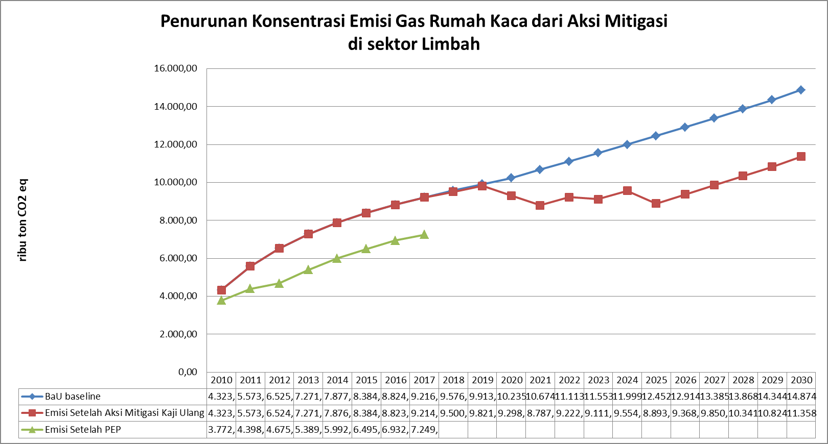

22,74

Gambar Lampiran 4. 1. Penurunan Emisi GRK dari Aksi Mitigasi Sektor Limbah